LAMPIRAN

LAMPIRAN A
INSTRUMEN PENELITIAN
A-1 PEDOMAN WAWANCARA
A-2 KISI-KISI ANGKET
A-3 ANGKET
A-4 LEMBAR VALIDASI PEDOMAN WAWANCARA
A-5 LEMBAR VALIDASI ANGKET

A- 1 Pedoman Wawancara
PEDOMAN WAWANCARA
“Analisis Kesalahan Mahasiswa dalam Menyelesaikan Masalah Pembuktian Geometri Berdasarkan Teori Newman”
No | Indikator Analisis Kesalahan Teori Newman | Pertanyaan
1. | Kesalahan membaca representasi simbol matematis (reading errors) | - Apakah penulisan simbol yang anda gunakan dalam penyelesaian soal tersebut sudah sesuai?
2. | Kesalahan memahami masalah pembuktian (comprehension errors) | - Apa yang diketahui pada soal tersebut?  - Dari pernyataan tersebut, apa yang akan Anda buktikan?
3. | Kesalahan mentransformasikan pembuktian (transformation errors) | - Dapatkah Anda memilih dan menentukan prosedur pembuktian yang sesuai?  - Bagaimana rencana pembuktian yang akan Anda lakukan?
4. | Kesalahan keterampilan proses pembuktian (process skills errors) | - Bagaimana Anda mengerjakan soal tersebut? Coba jelaskan setiap langkah dan alasannya.
5. | Kesalahan penulisan jawaban (encoding errors) | - Apakah hasil jawaban Anda sudah sesuai dengan permintaan pada soal?  - Dapatkah Anda menemukan jawaban dengan cara lain?

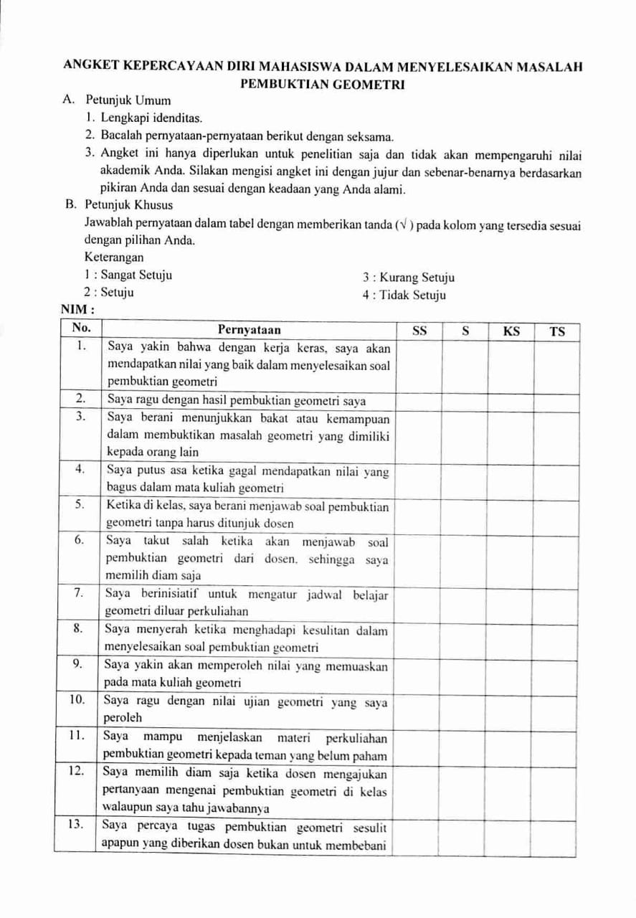
A- 2 Angket

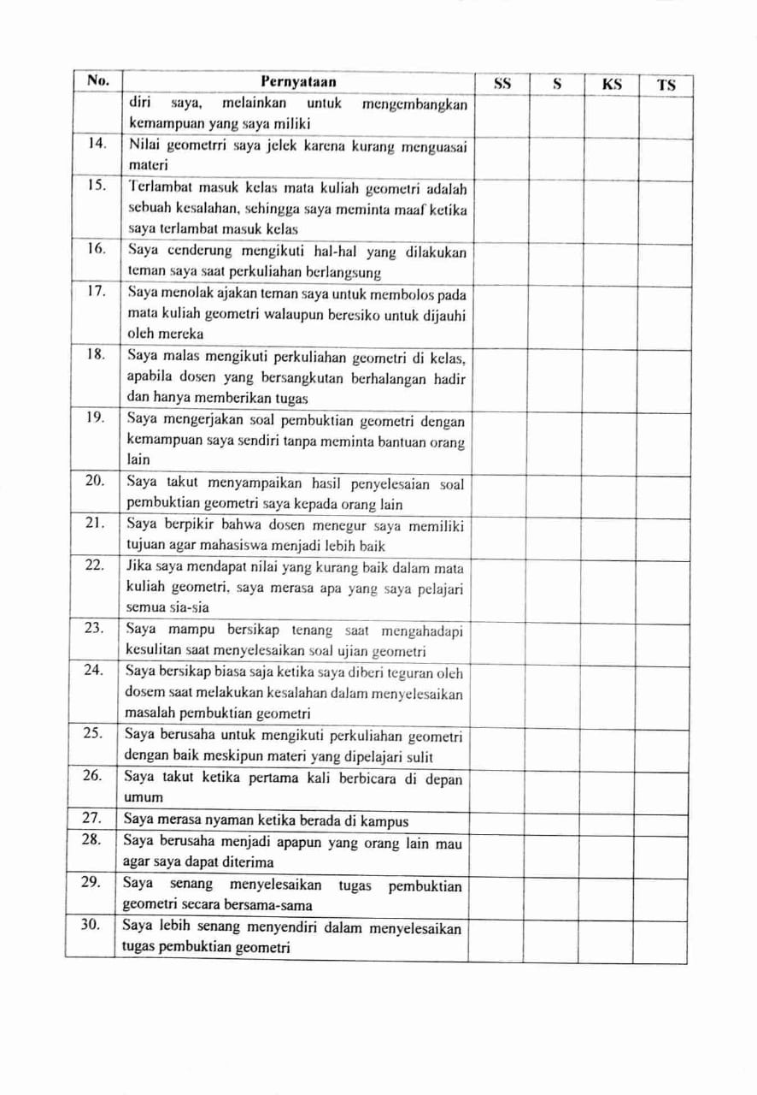

A- 3 Kisi-kisi Angket
KISI-KISI ANGKET KEPERCAYAAN DIRI MAHASISWA DALAM MENYELESAIKAN MASALAH PEMBUKTIAN GEOMETRI
No. | Aspek | Indikator | Nomor Item
No. | Aspek | Indikator | Positif | Negatif
1. | Mahasiswa mempunyai keyakinan akan kemampuan diri | Mahasiswa yakin dengan kemampuan yang dimilikinya. | 1 | 2
1. | Mahasiswa mempunyai keyakinan akan kemampuan diri | Mahasiswa mempunyai sikap positif tentang dirinya | 3 | 4
1. | Mahasiswa mempunyai keyakinan akan kemampuan diri | Mahasiswa berani bertanya dan menyatakan pendapatnya. | 5 | 6
2. | Mahasiswa mempunyai sikap optimis | Mahasiswa mempunyai sikap positif dalam segala hal diri | 7 | 8
2. | Mahasiswa mempunyai sikap optimis | Mahasiswa mempunyai sikap positif tentang harapan | 9 | 10
2. | Mahasiswa mempunyai sikap optimis | Mahasiswa mempunyai sikap poitif tentang kemampuannya | 11 | 12
3. | Mahasiswa mempunyai sikap objektif | Mahasiswa memandang permasalahan atau sesuatu sesuai dengan kebenaran yang semestinya | 13 | 14
3. | Mahasiswa mempunyai sikap objektif | Mahasiswa mampu membedakan fakta dan opini | 15 | 16
4. | Mahasiswa mempunyai sikap tanggungjawab | Mahasiswa bersedia untuk menanggung segala sesuatu yang telah menjadi konsekuensinya | 17 | 18
4. | Mahasiswa mempunyai sikap tanggungjawab | Bertindak mandiri dalam mengambil keputusan | 19 | 20
5. | Mahasiswa mempunyai sikap rasional | Mahasiswa menganalisa sesuatu kejadian dengan menggunakan pemikiran yang dapat diterima oleh akal | 21 | 22
5. | Mahasiswa mempunyai sikap rasional | Mahasiswa dapat menganalisa sesuatu kejadian dengan menggunakan pemikiran yang sesuai kenyataan | 23 | 24
6. | Mahasiswa berani mencoba hal baru tanpa rasa takut | Mahasiswa berani mencoba sesuatu hal yang baru | 25 | 26
7. | Mahasiswa merasa dapat diterima oleh lingkungan tempat berinteraksi | Mahasiswa yakin bahwa dirinya akan dapat diterima ditengah-tengah lingkungan universitas | 27 | 28
7. |  | Mahasiswa mampu bersosialisasi dengan baik di lingkungan universitas | 29 | 30
A- 4 Lembar Validasi Pedoman Wawancara
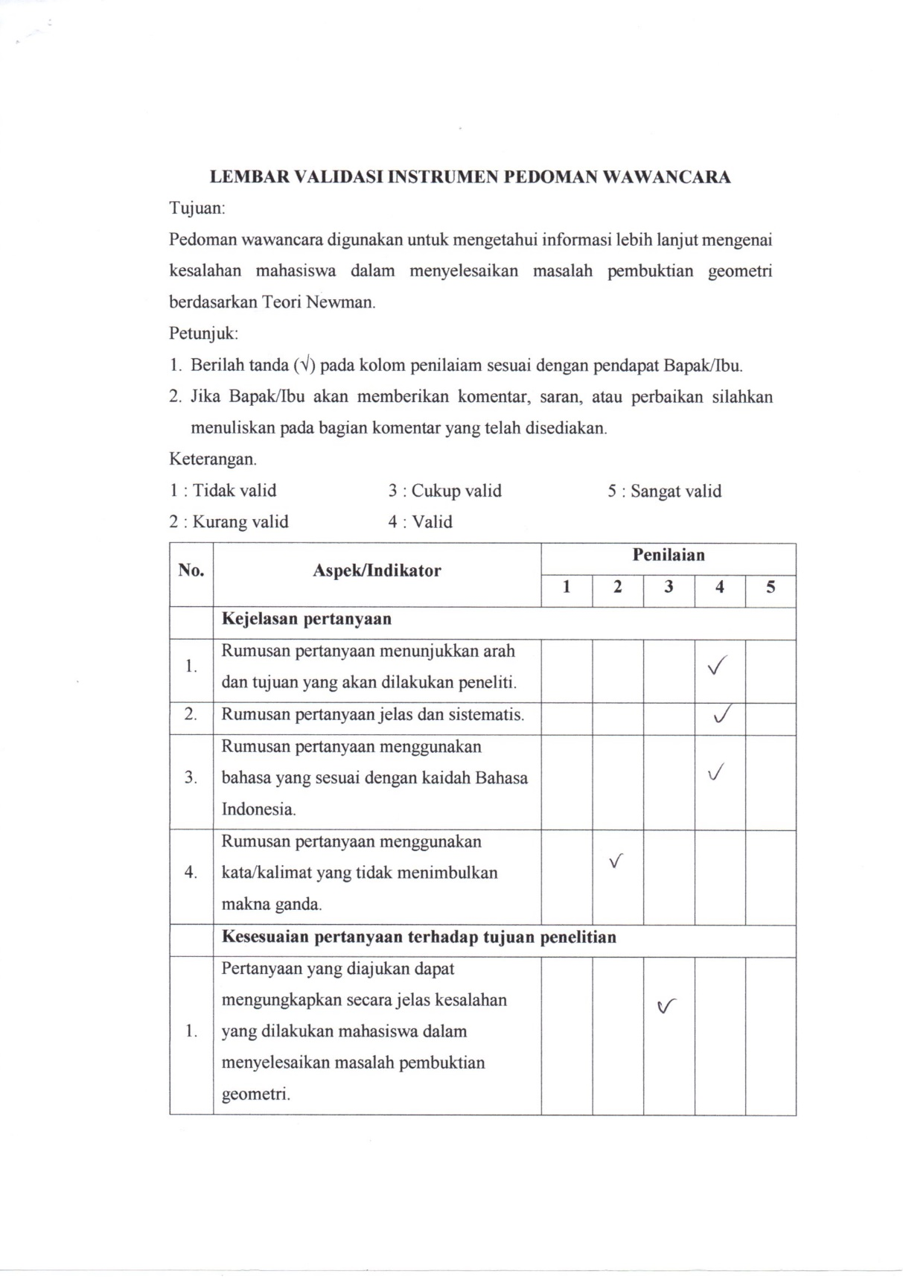

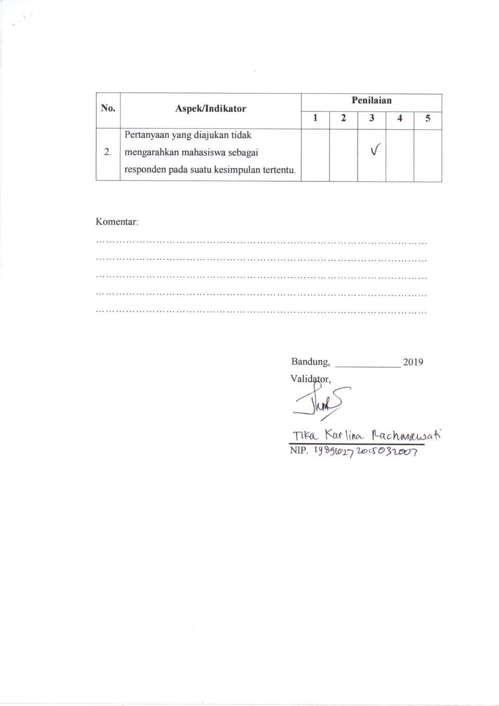

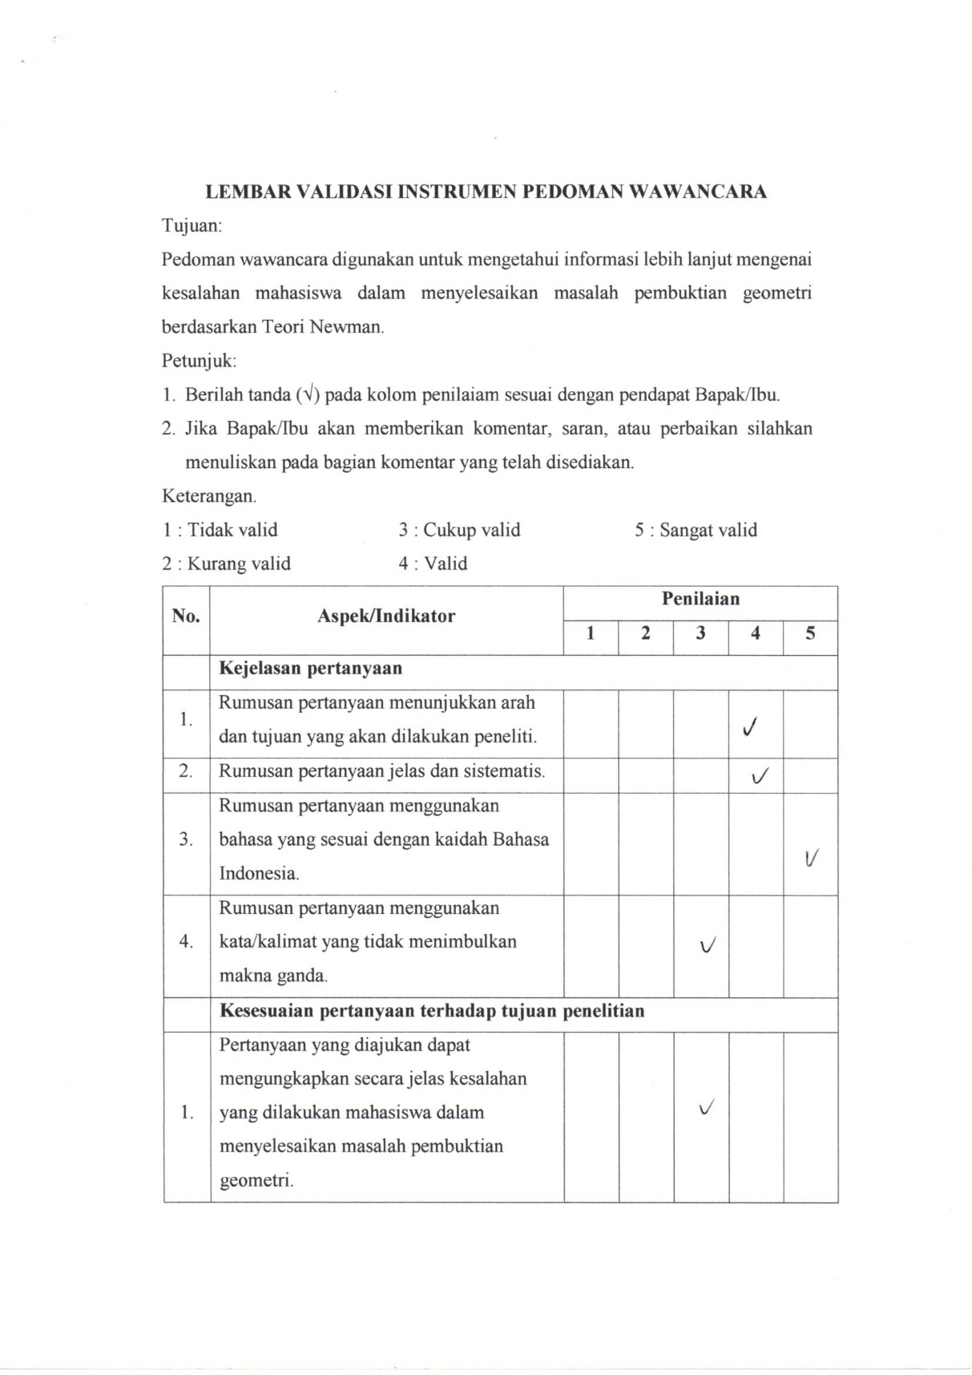

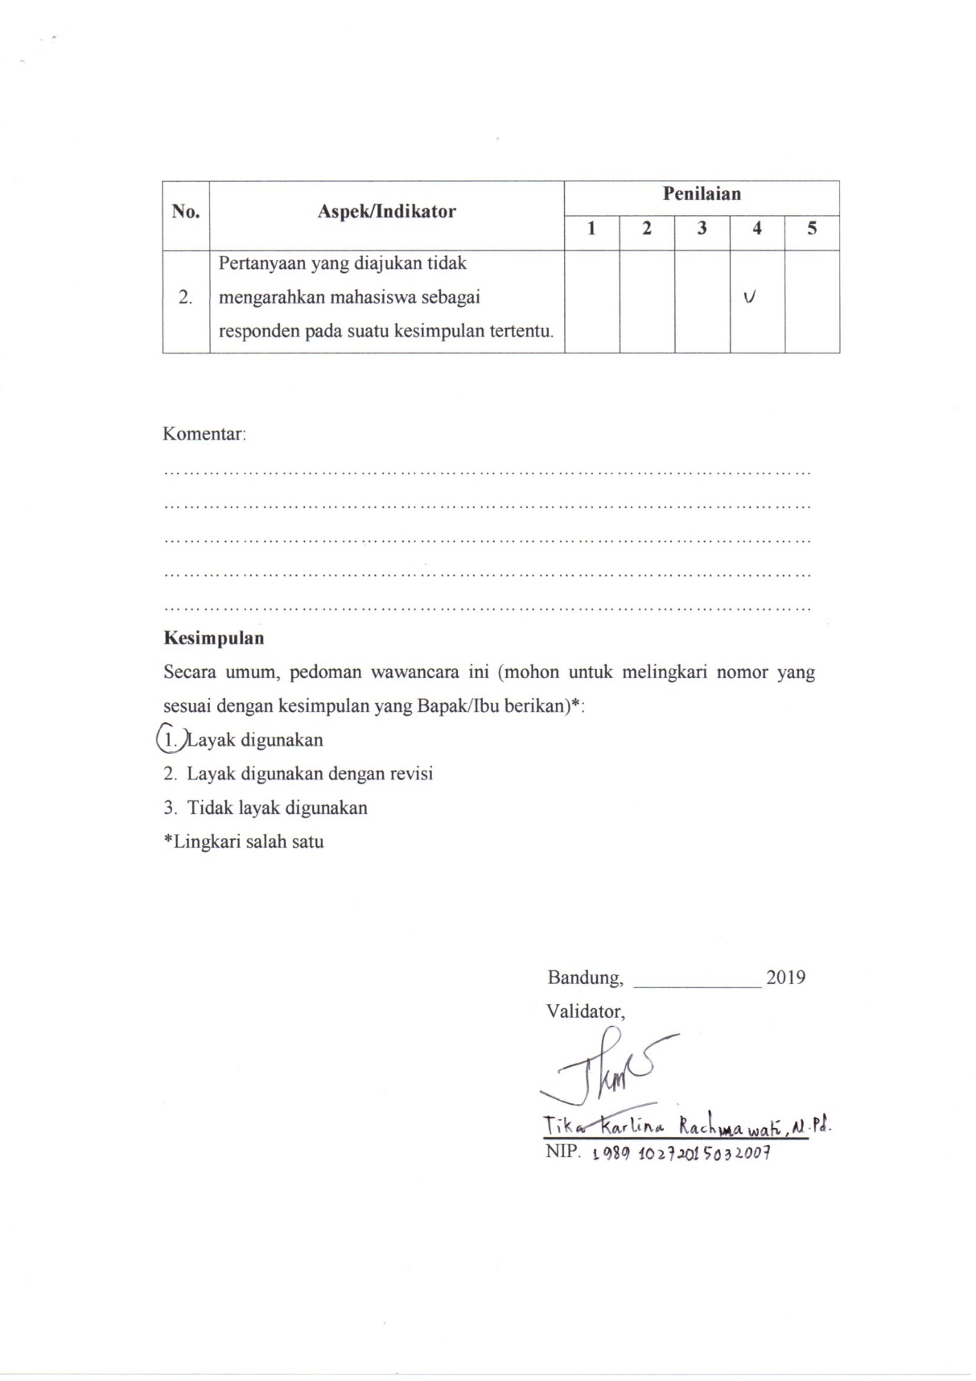

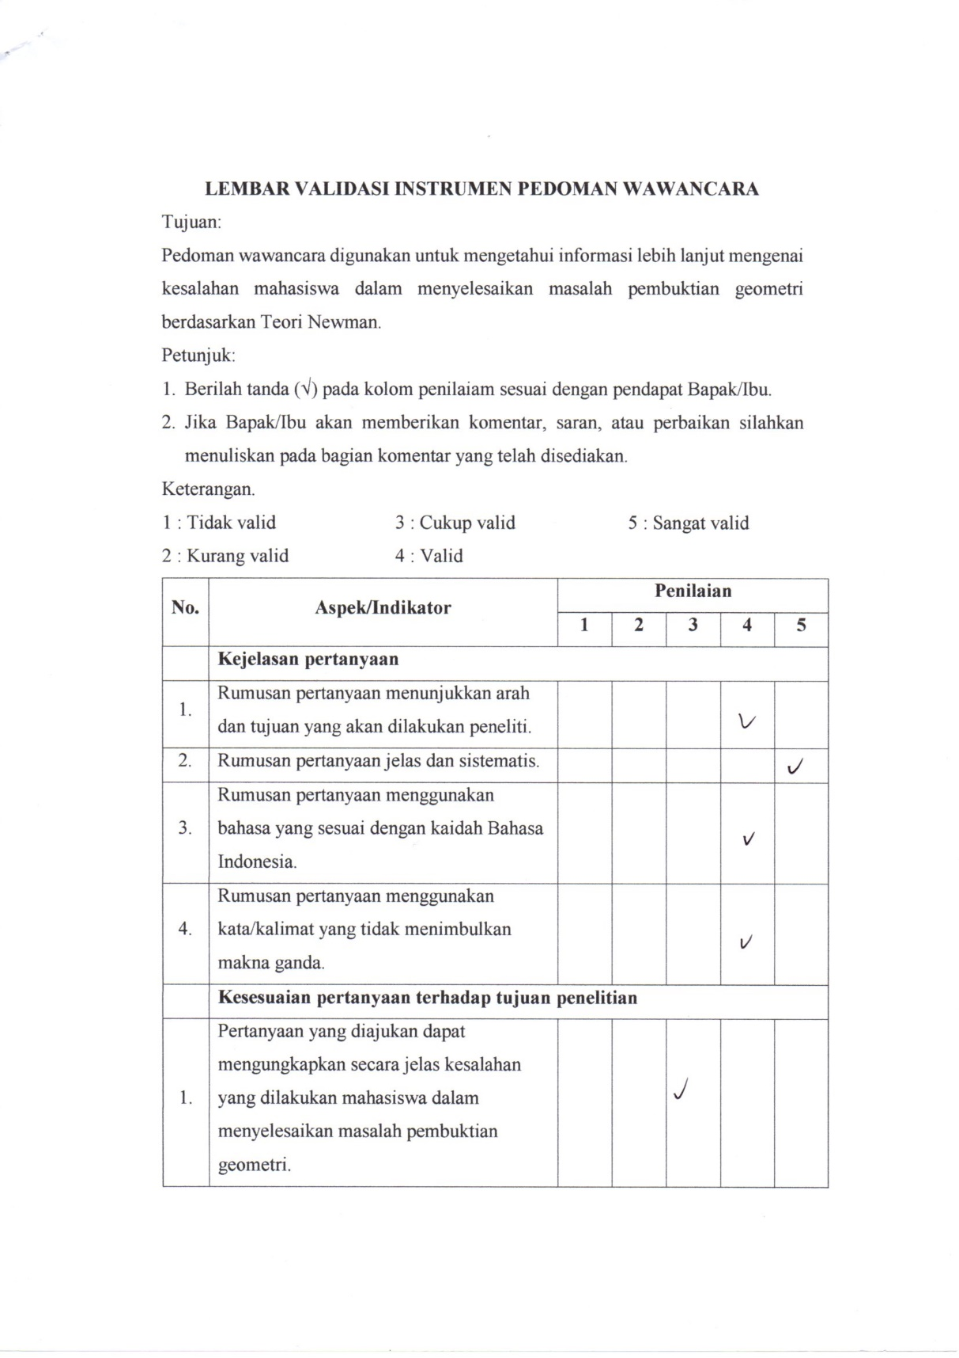

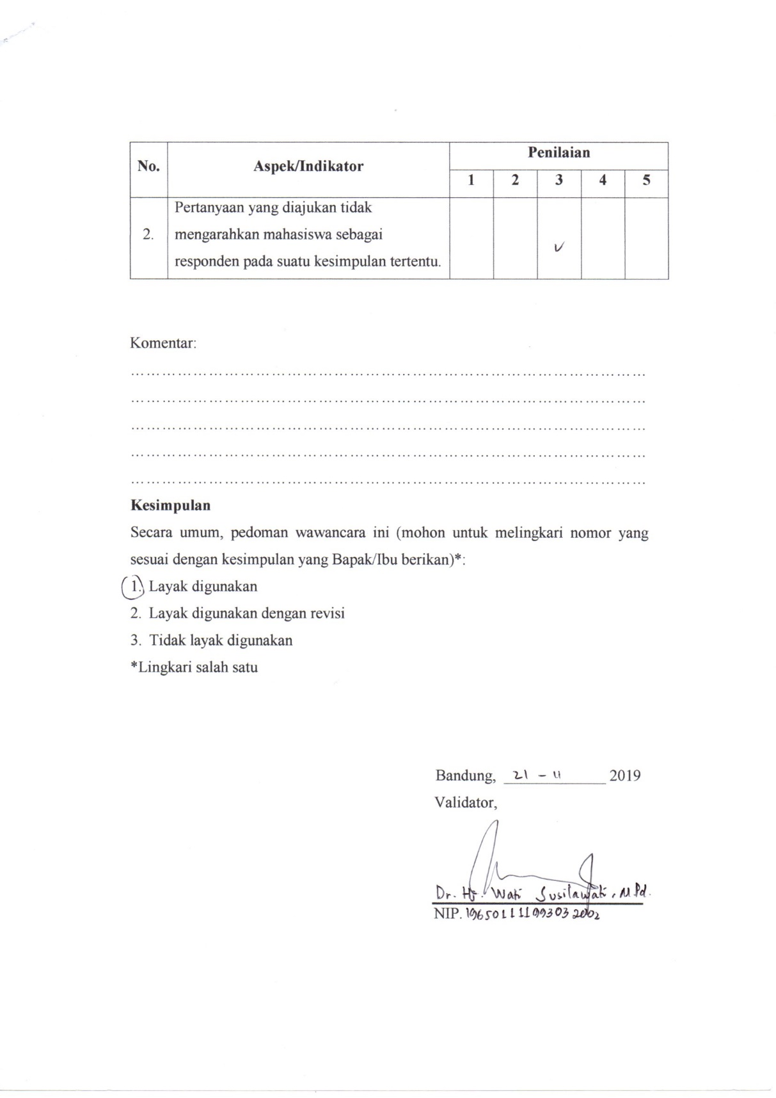

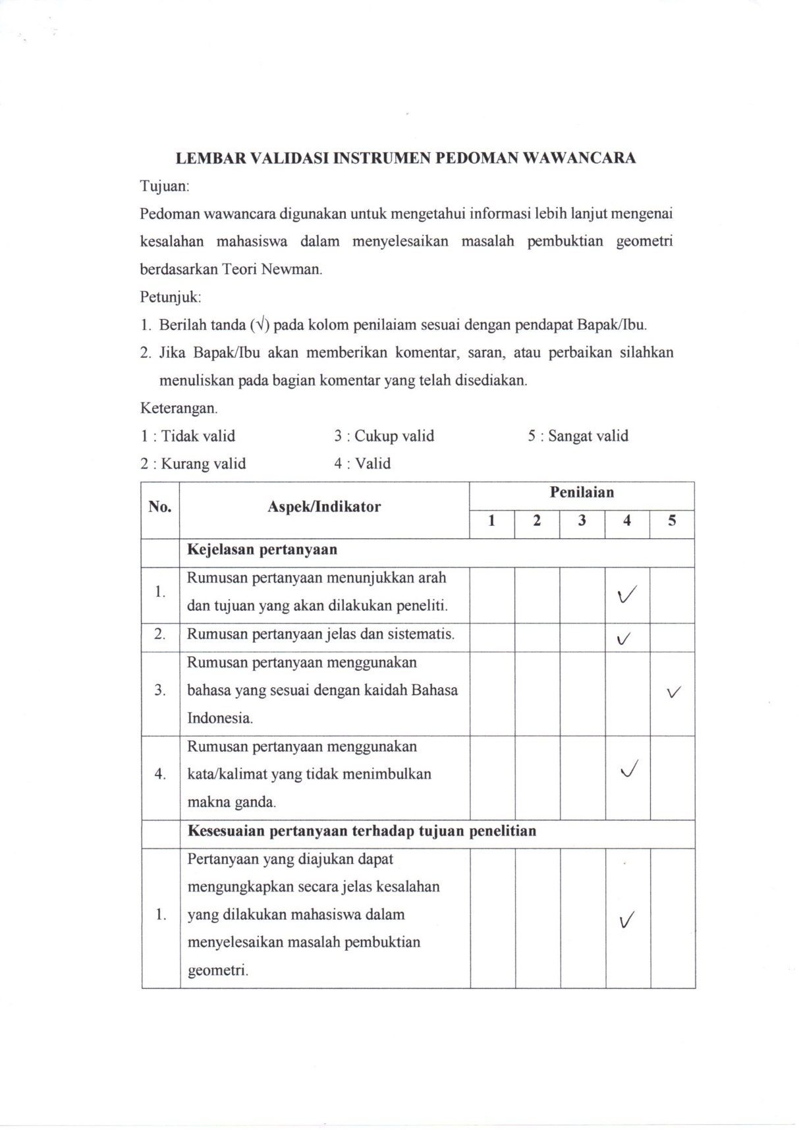

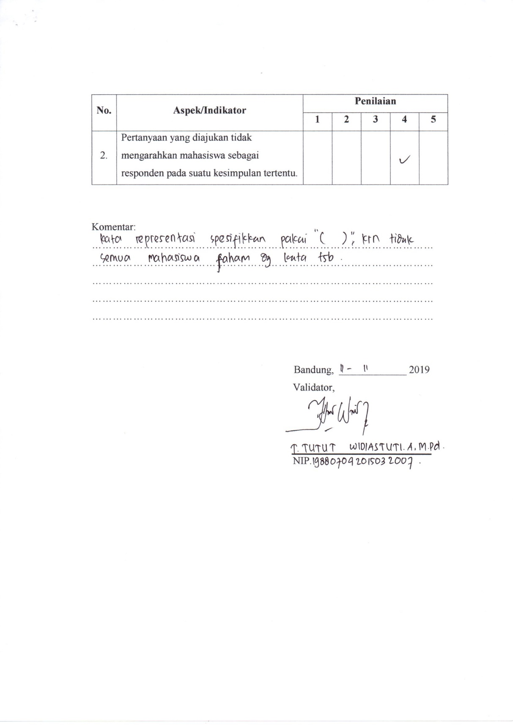

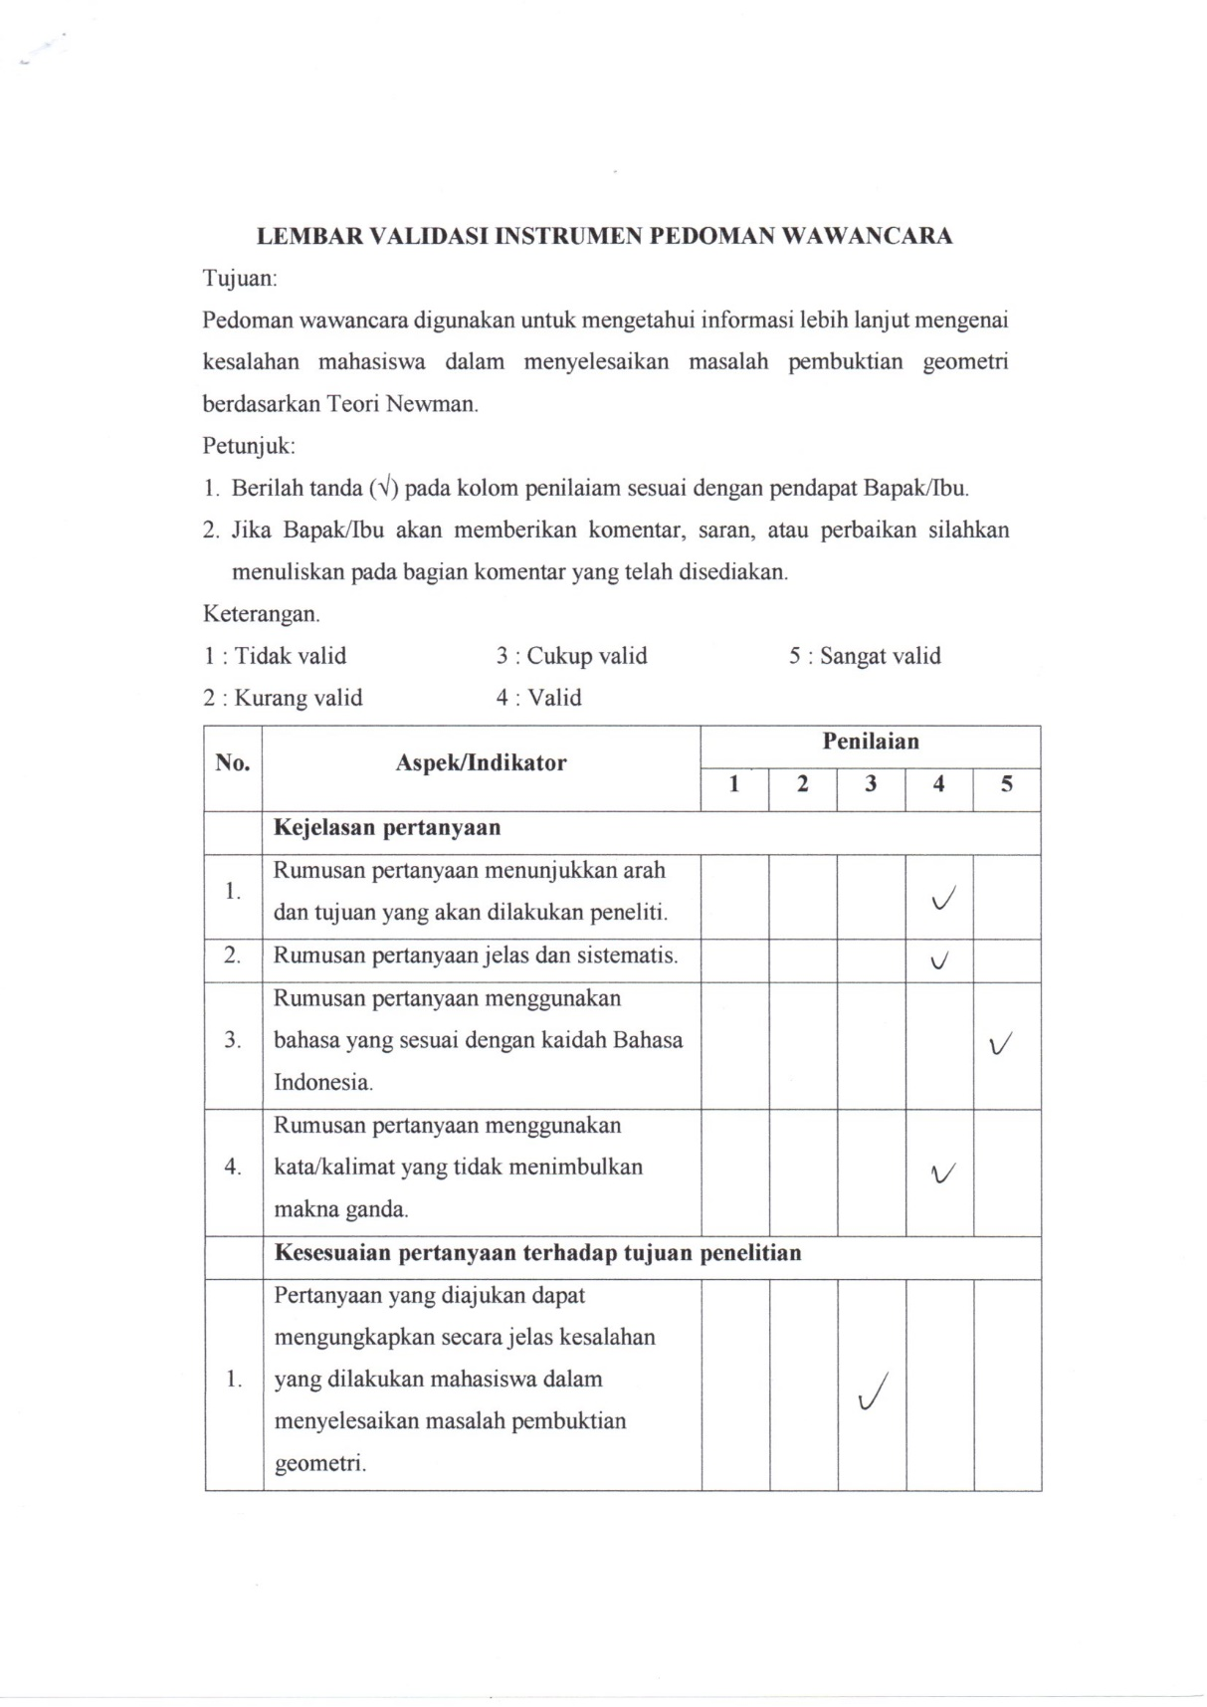

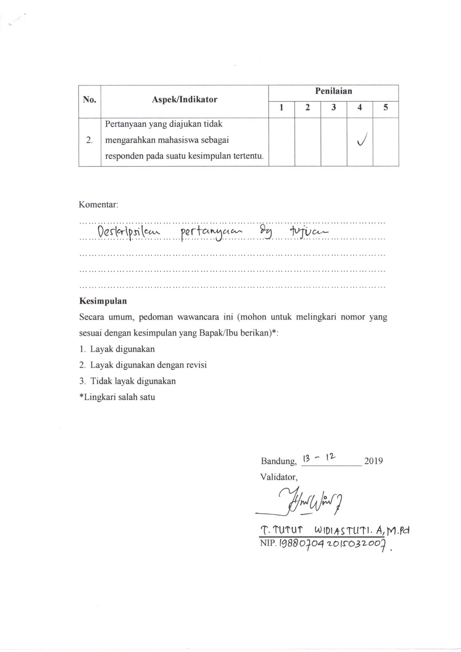

A- 5 Lembar Validasi Angket
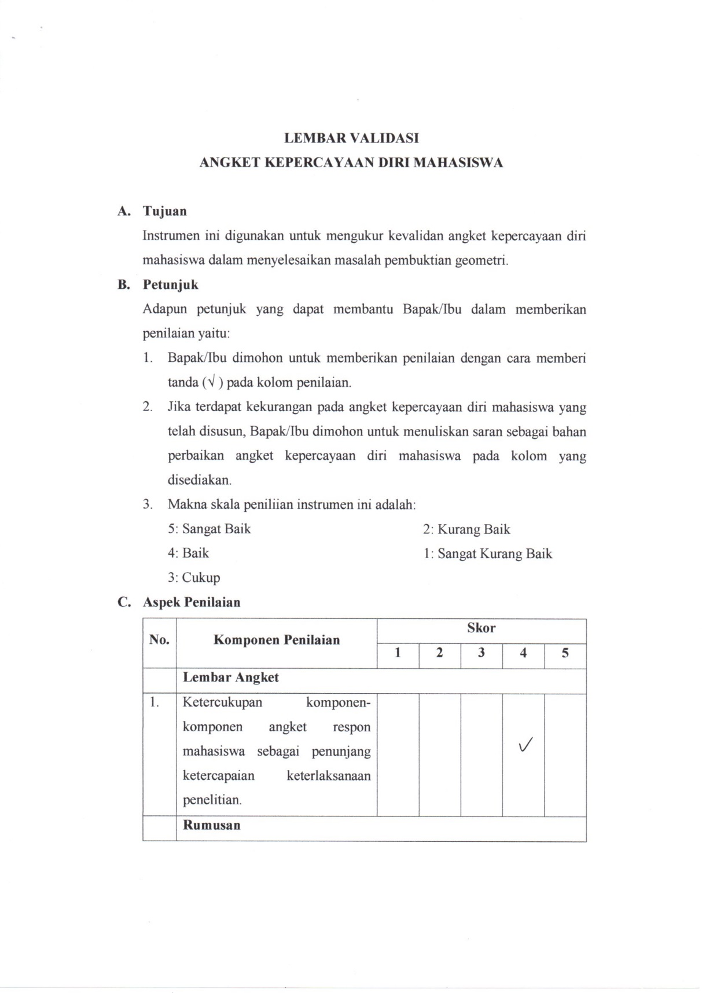
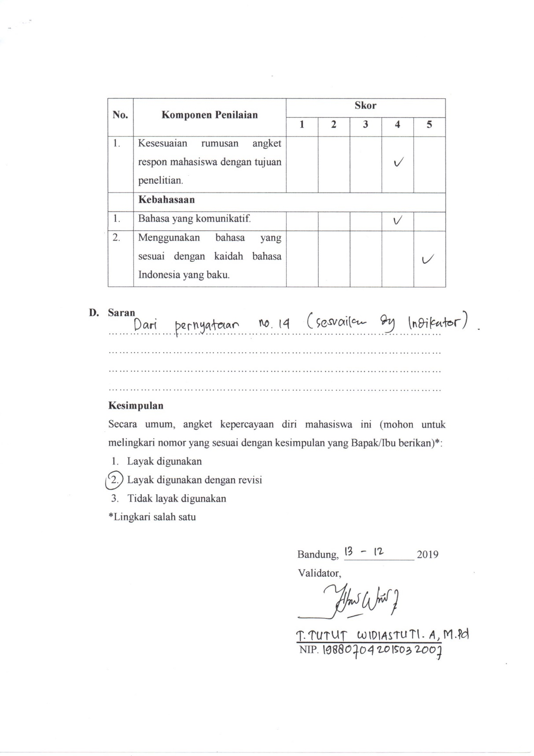

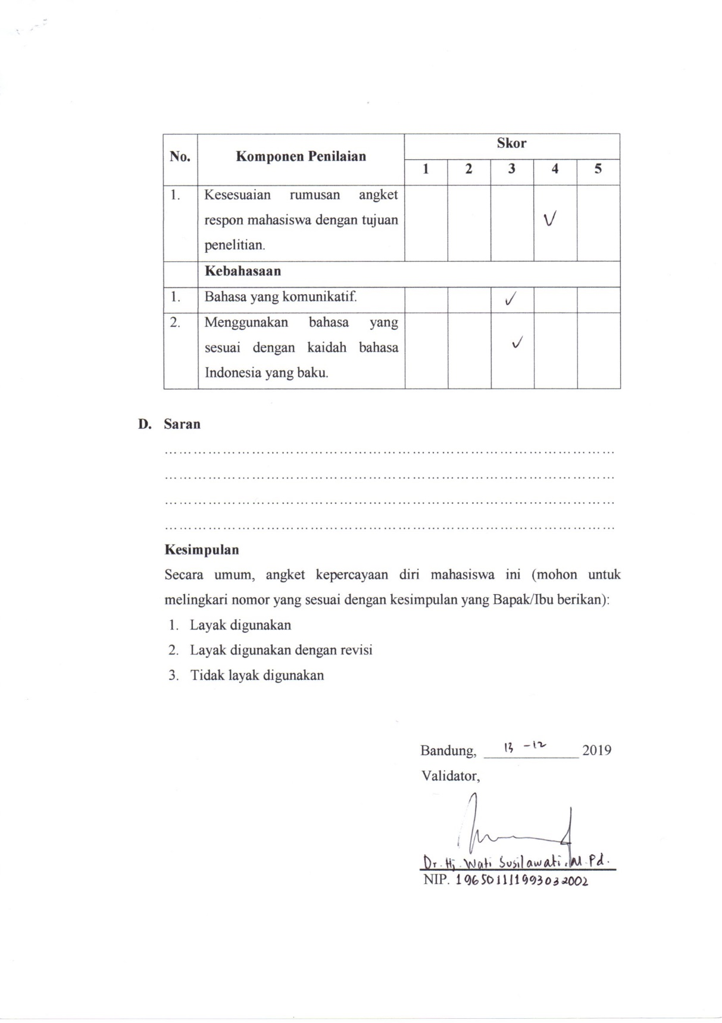

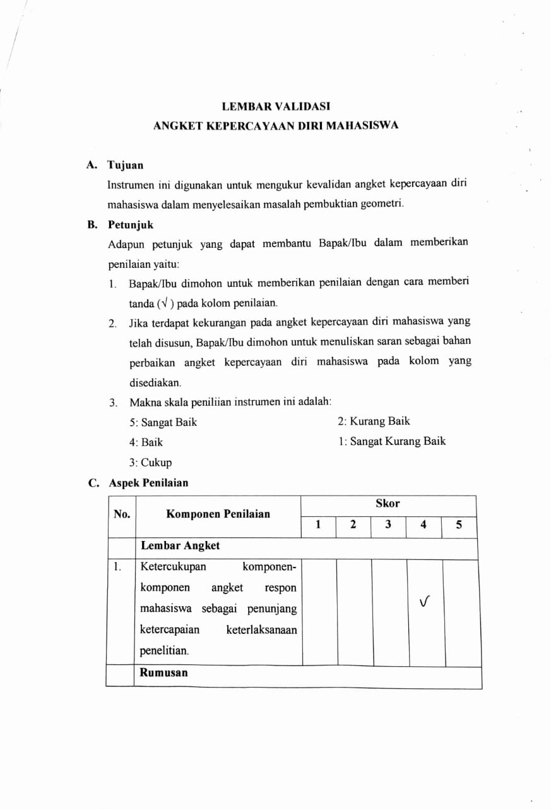

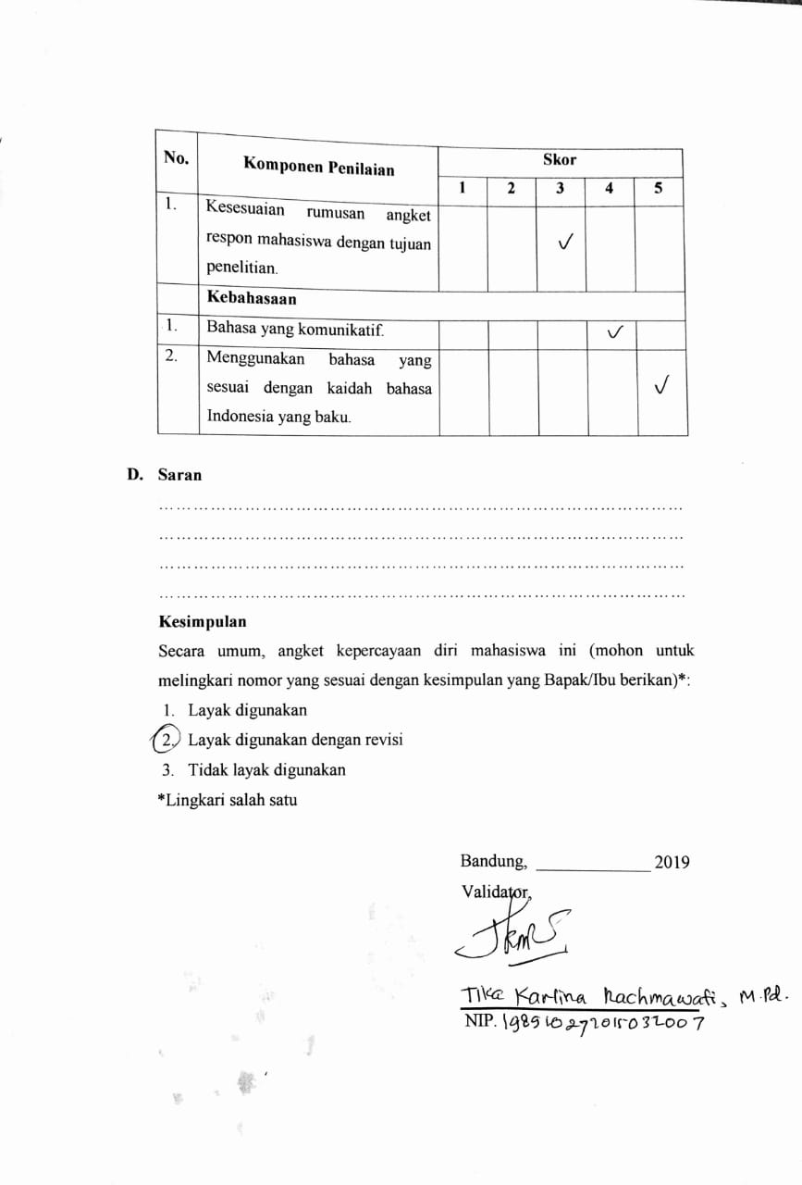

LAMPIRAN B
BUKTI DATA PENELITIAN
B-1 LEMBAR JAWABAN UTS
B-2 LEMBAR JAWABAN UAS
B-3 LEMBAR JAWABAN KUIS
B-4 LEMBAR JAWABAN ANGKET

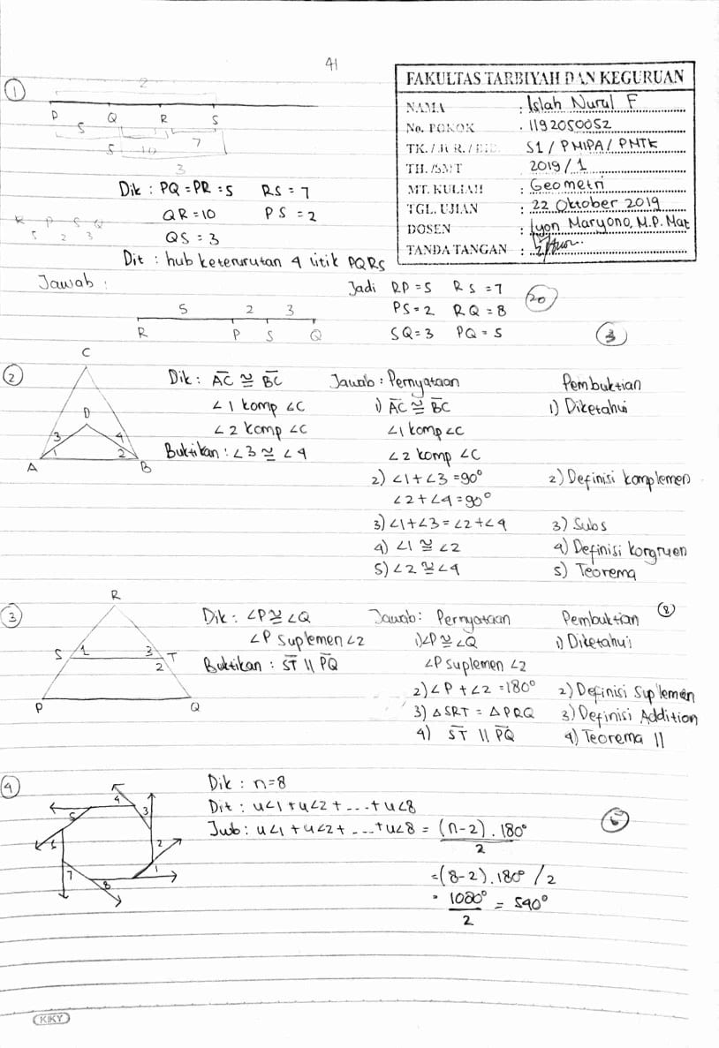
B- 1 Lembar Jawaban UTS

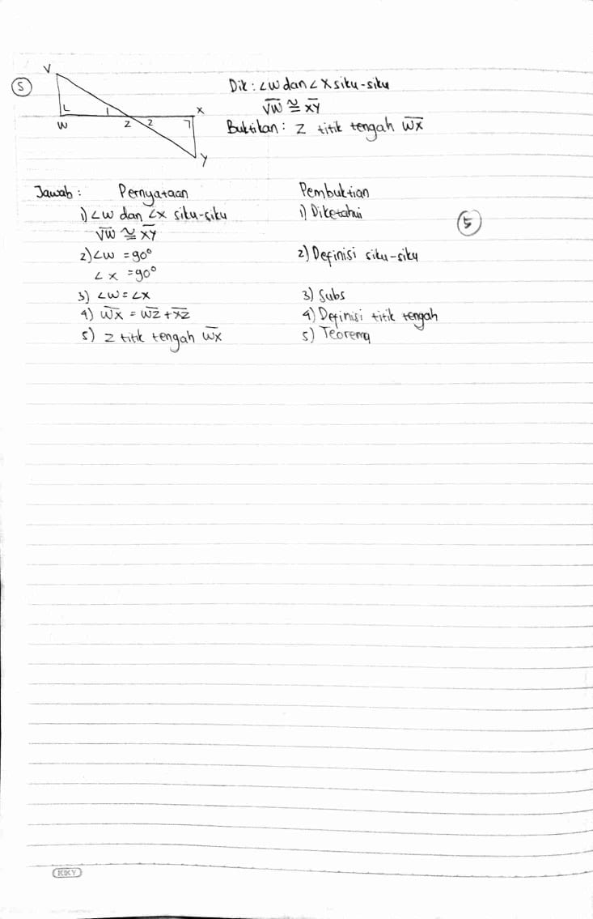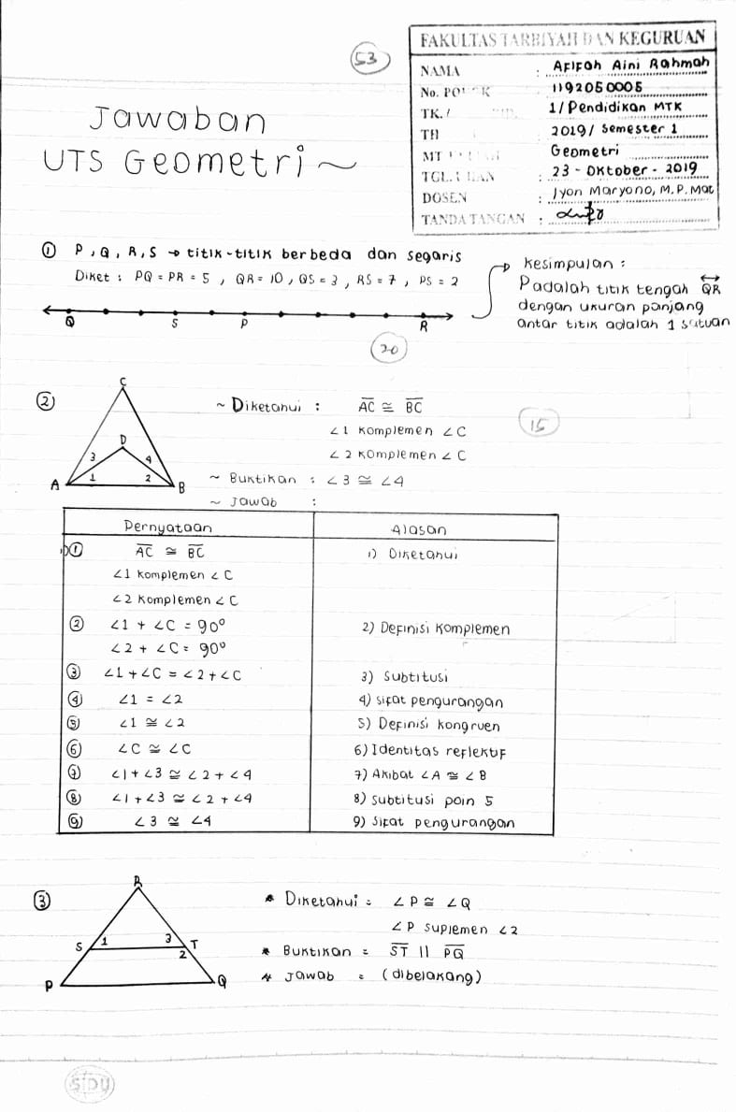

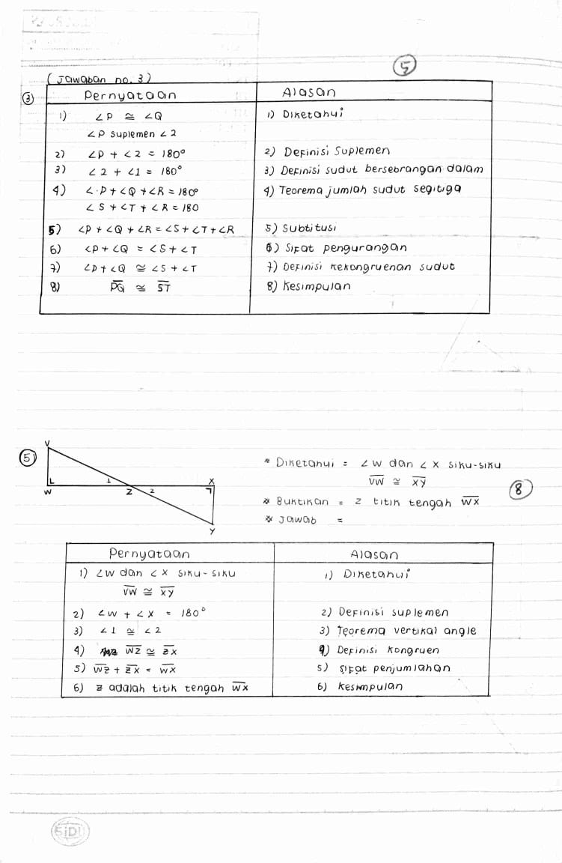

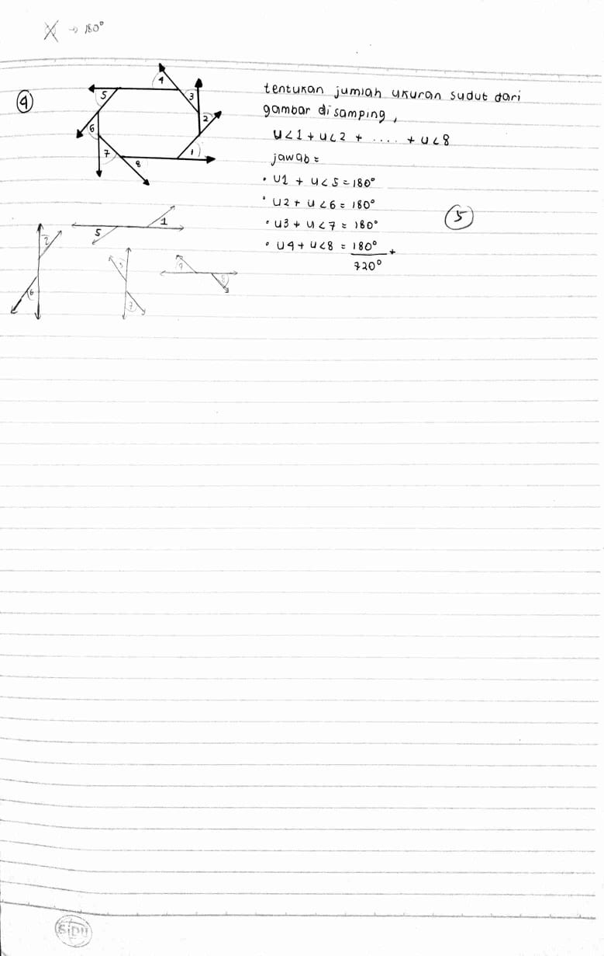
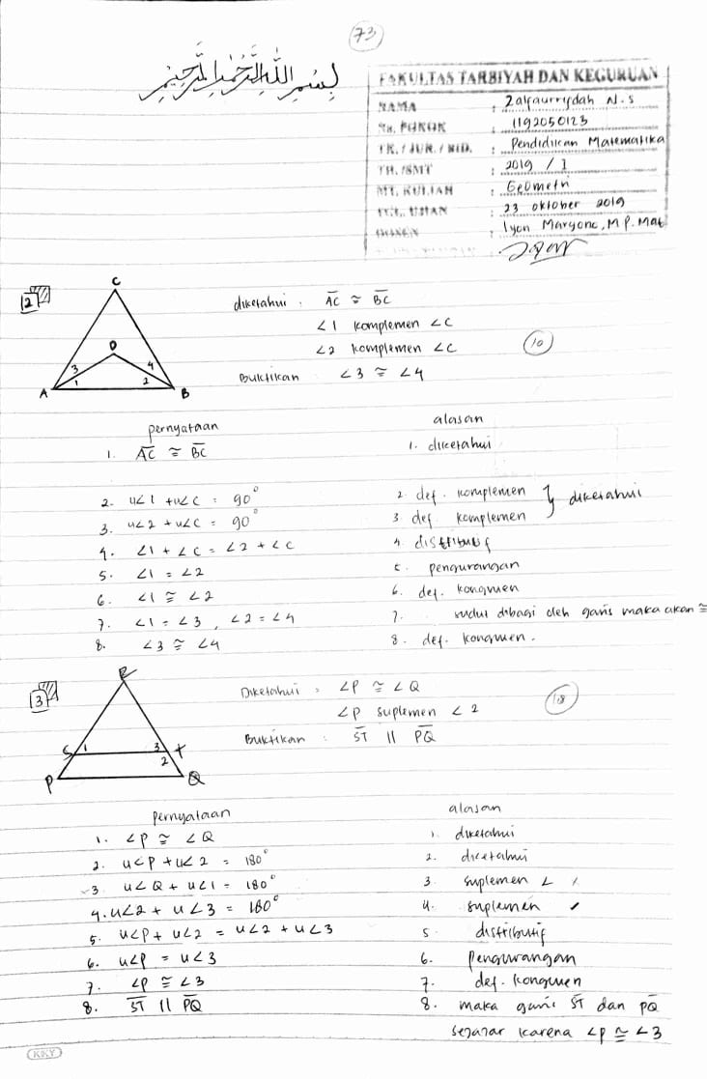

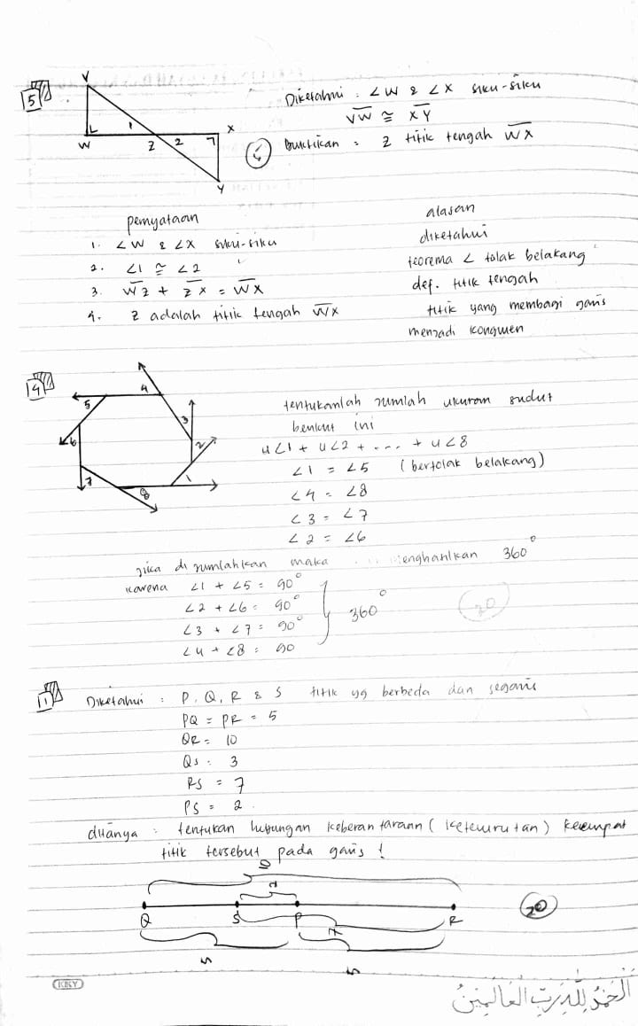
B- 2 Lembar Jawaban UAS
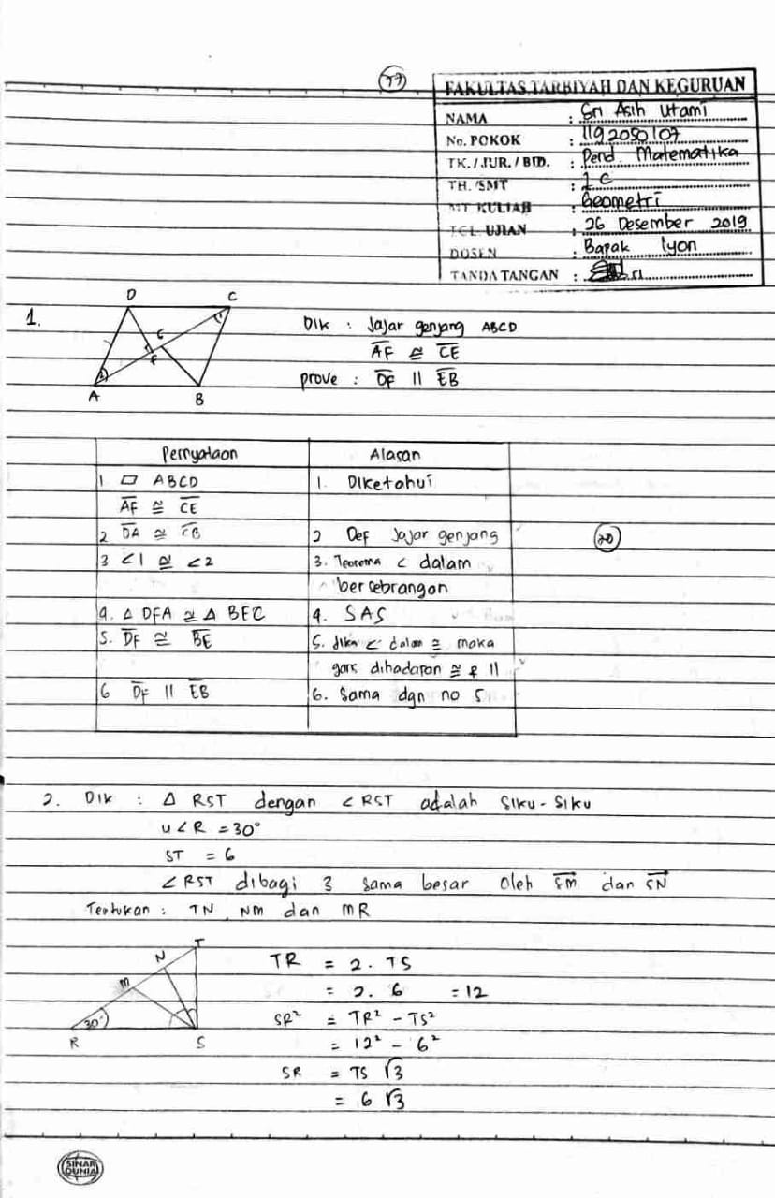
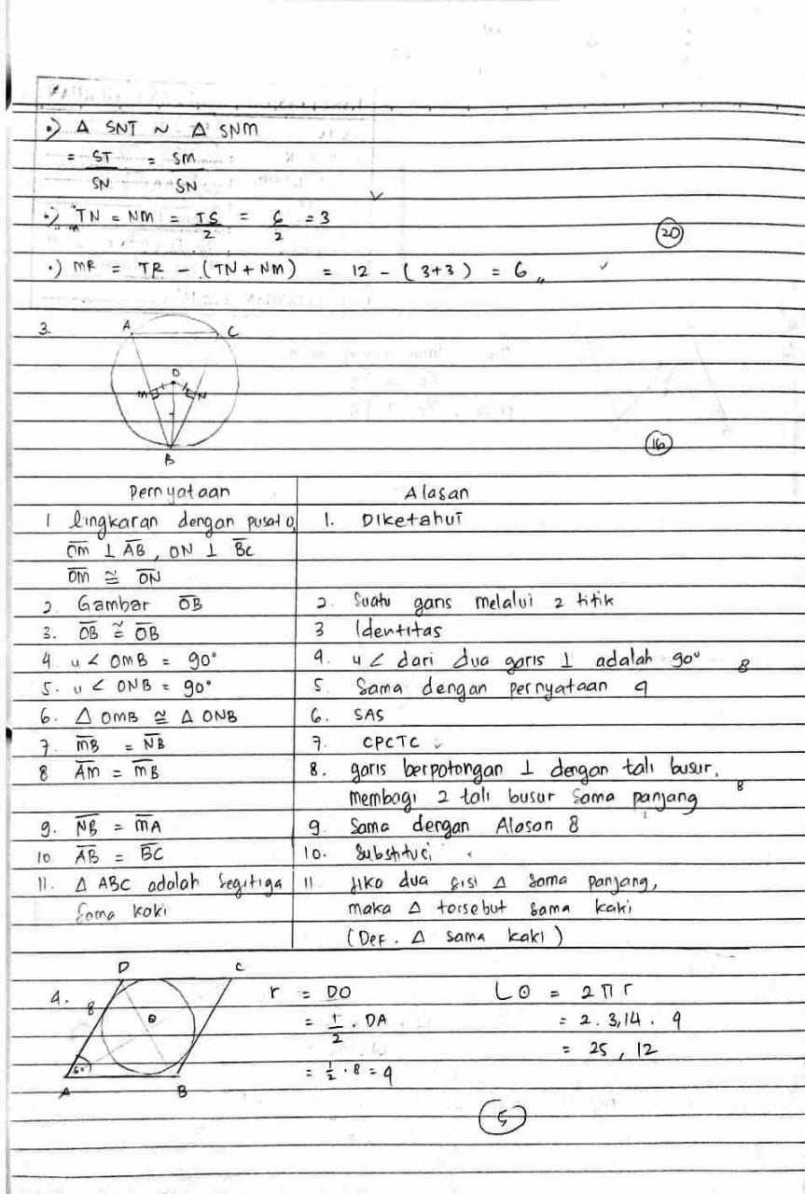

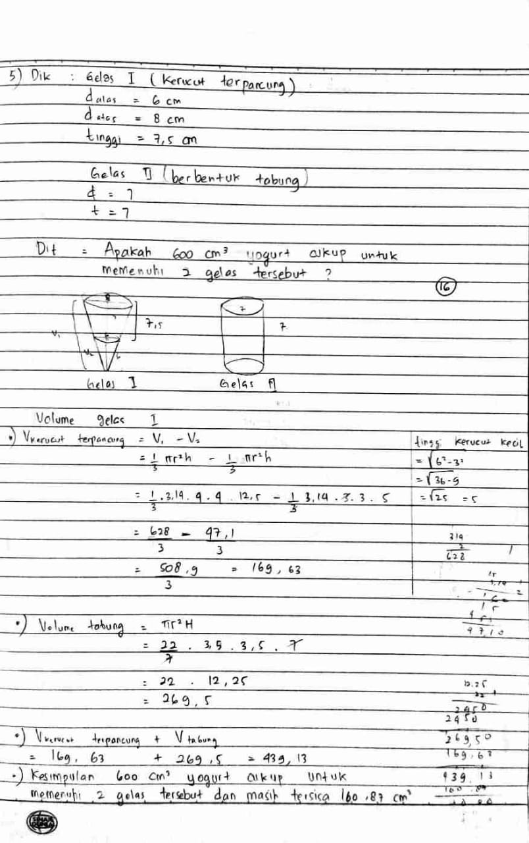
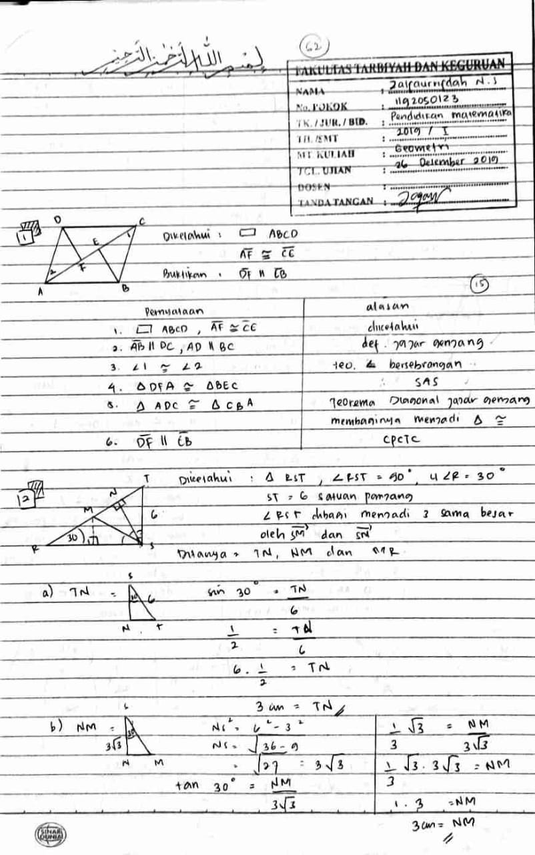
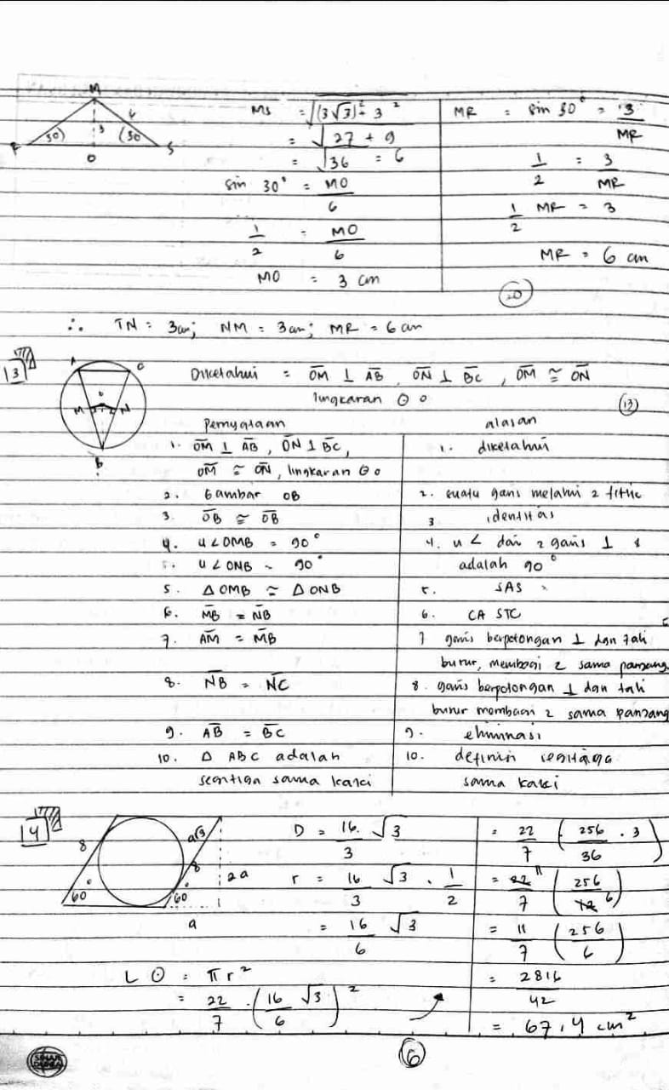
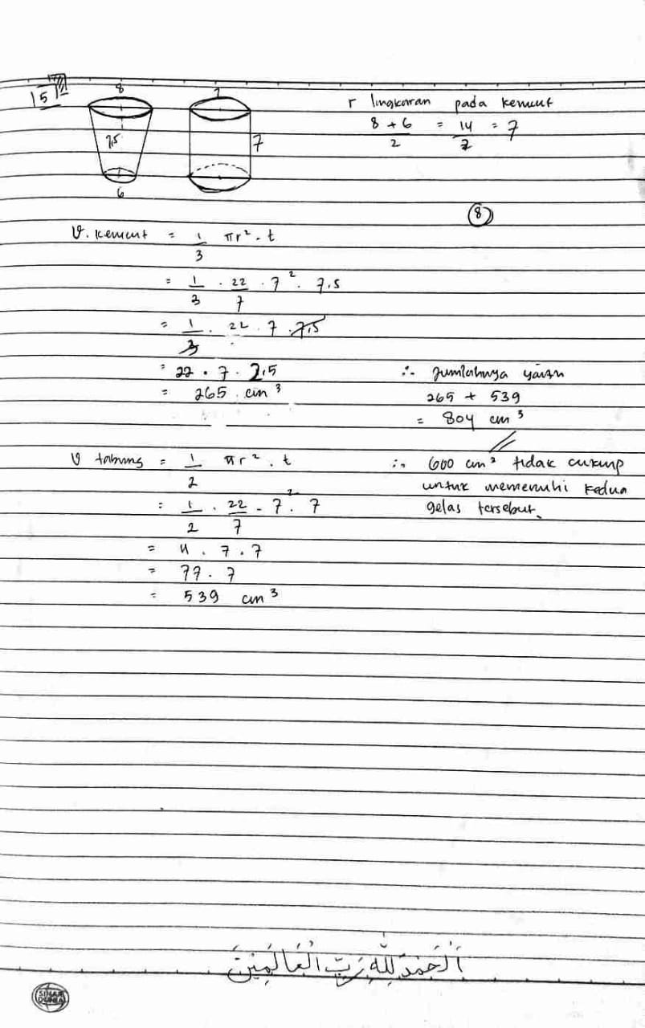
B- 3 Lembar Jawaban Kuis
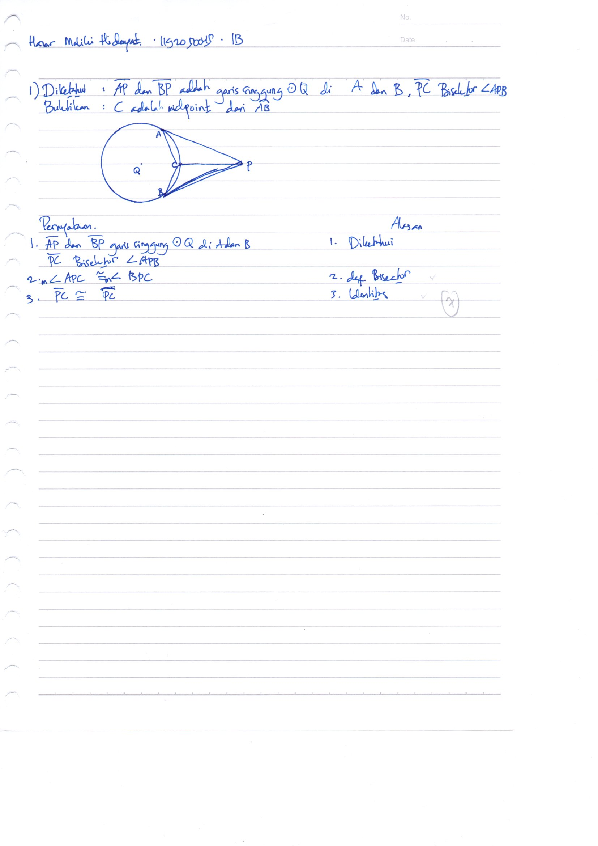

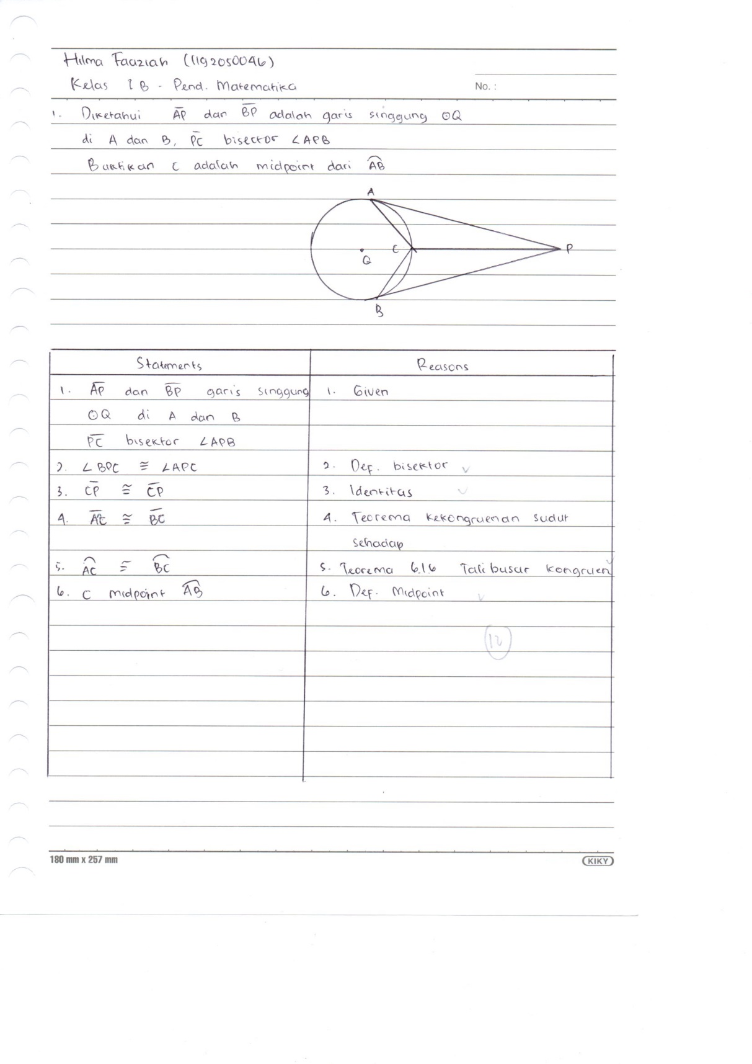

B- 4 Lembar Jawaban Angket
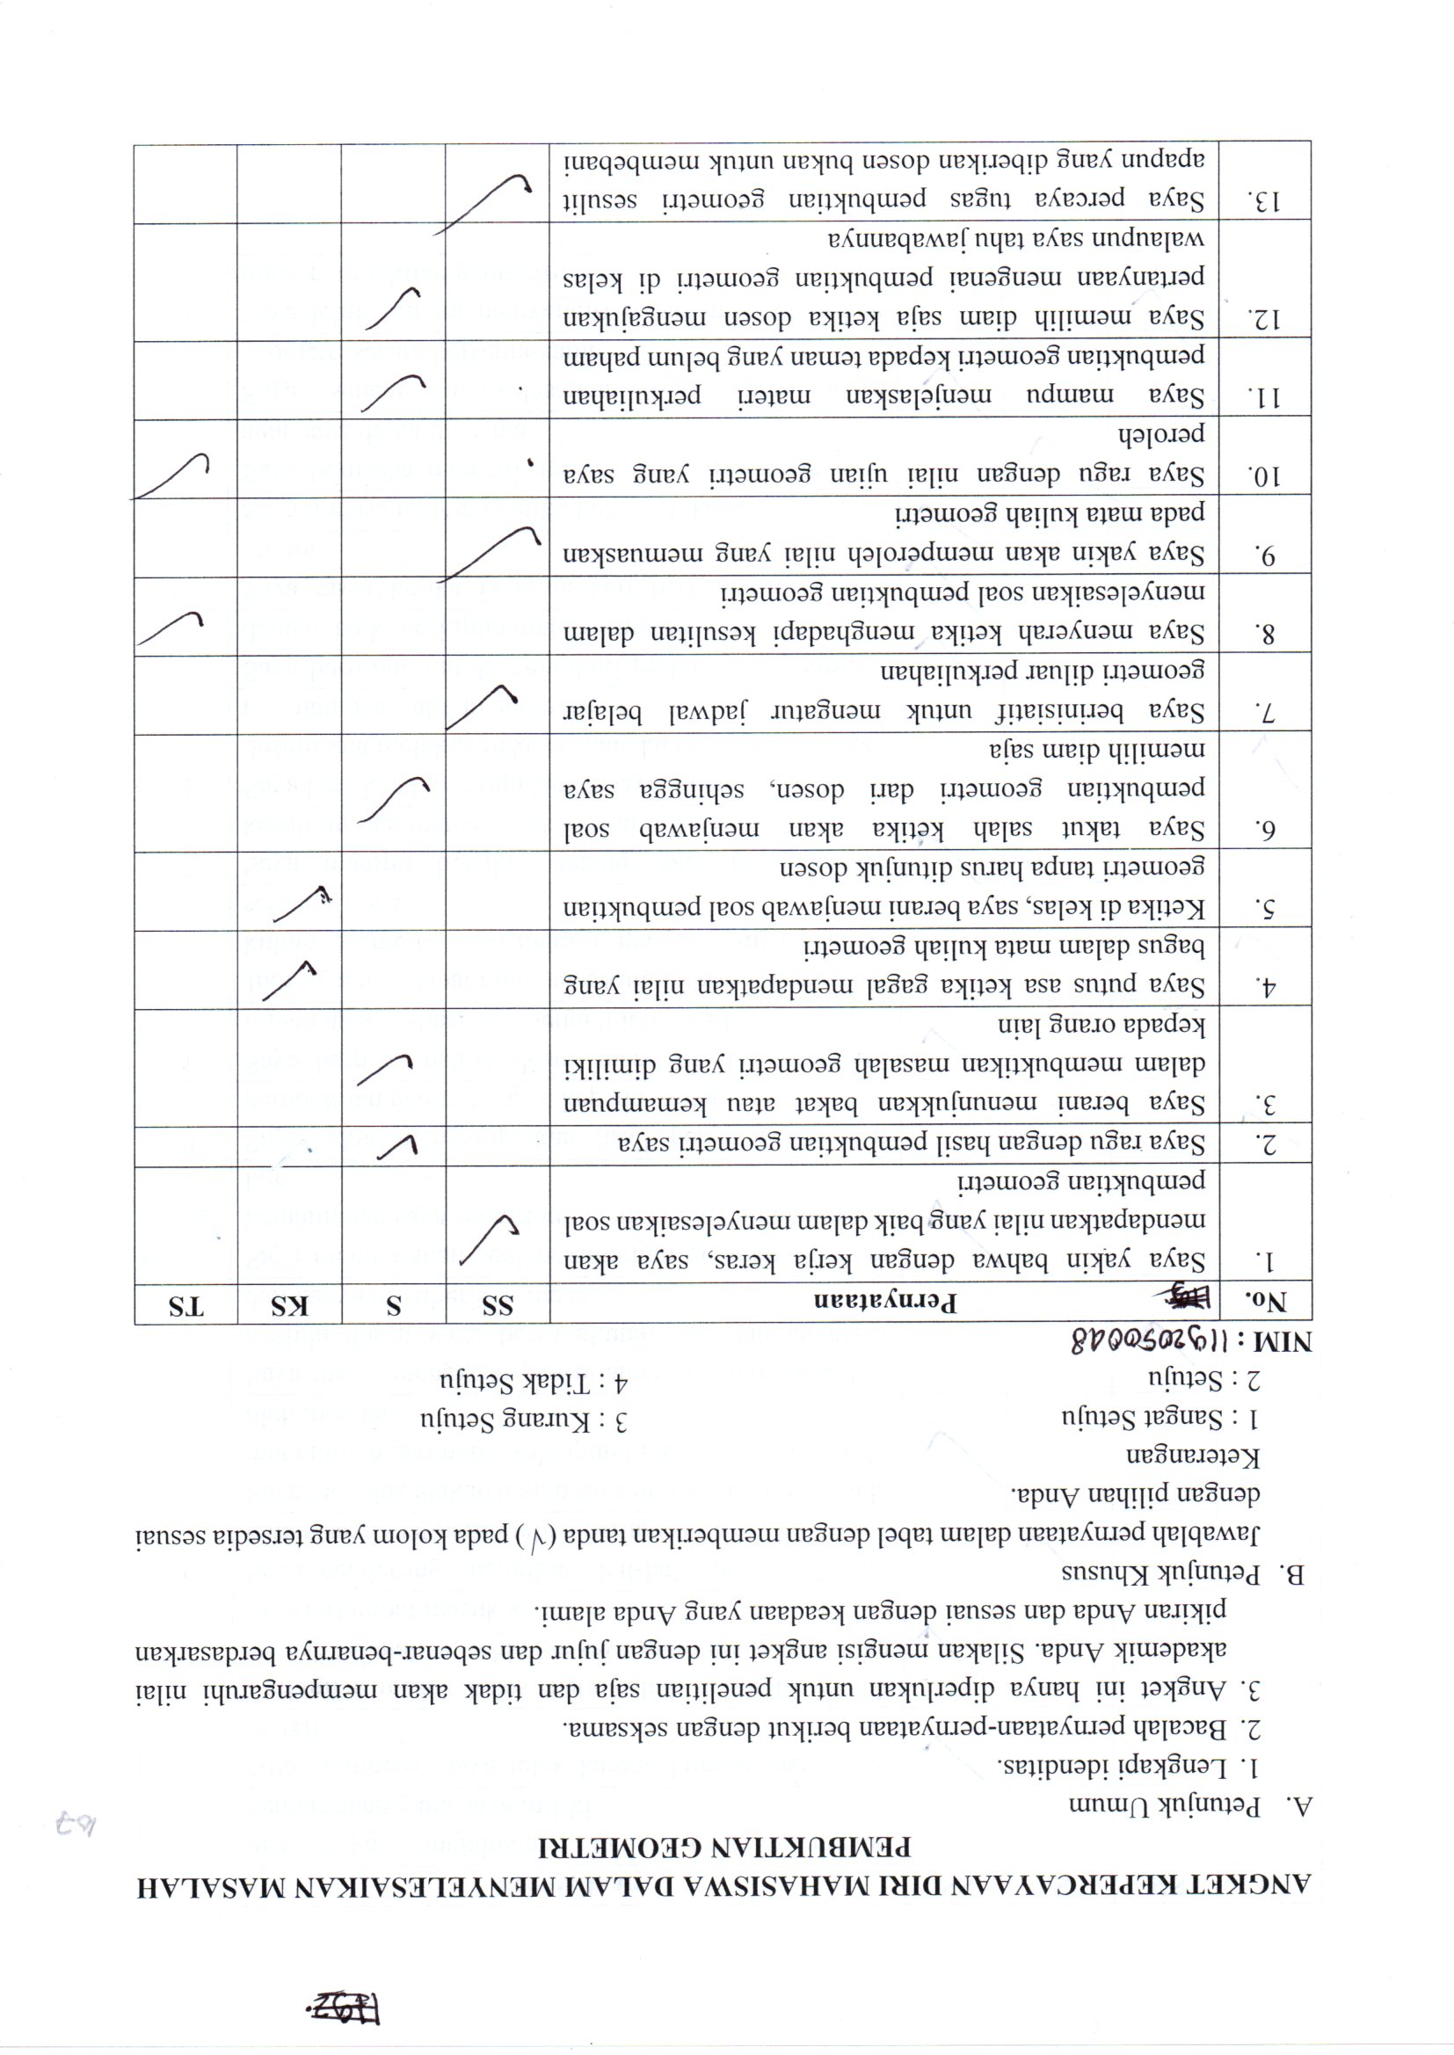

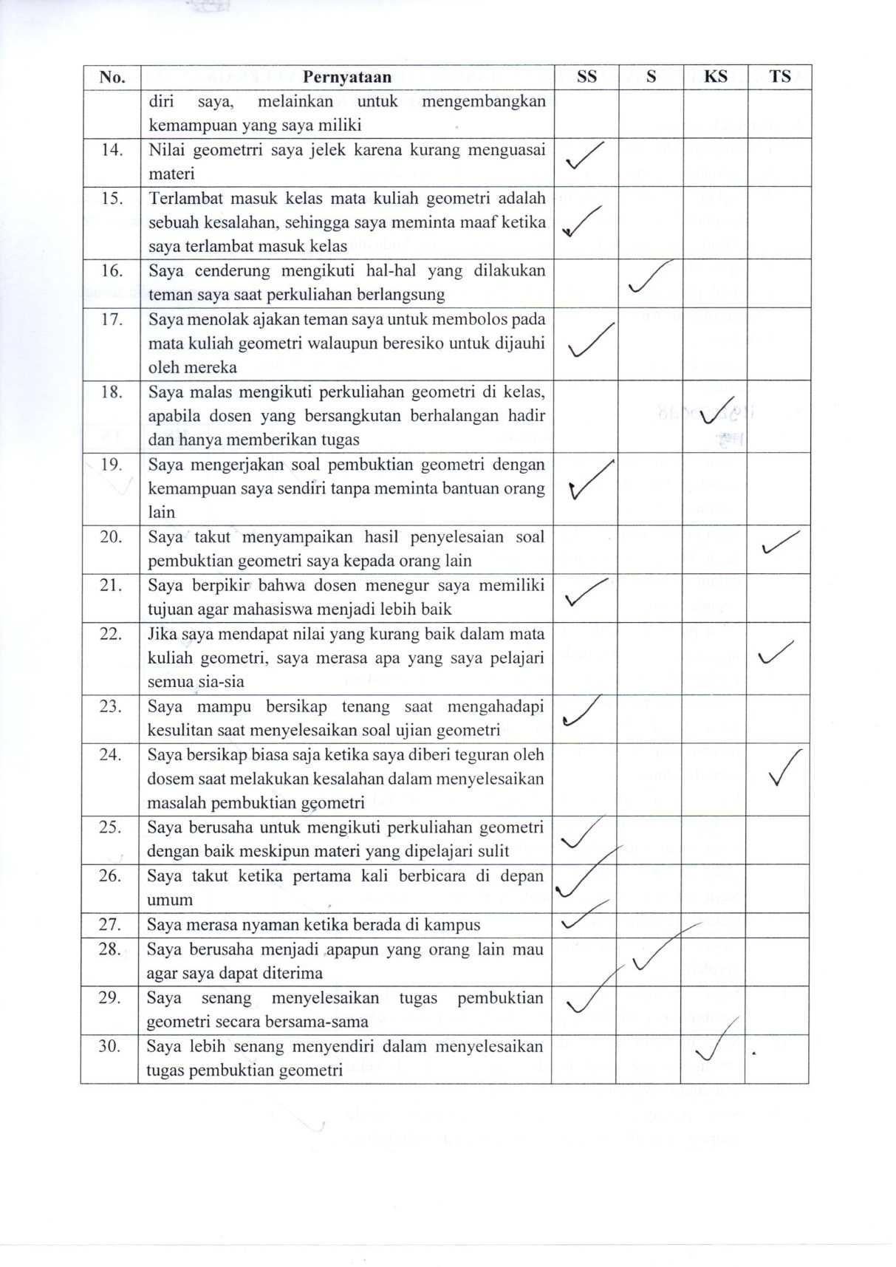

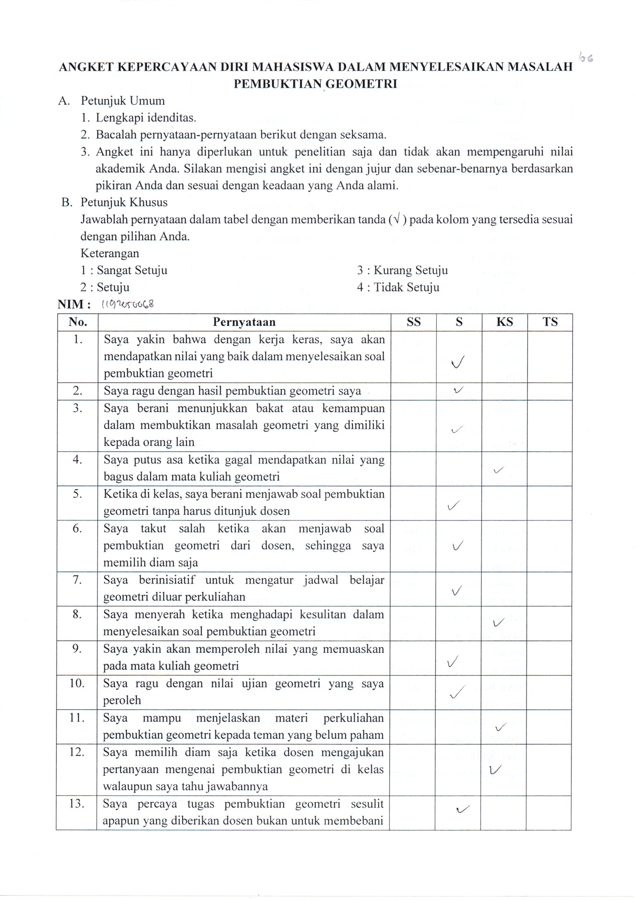

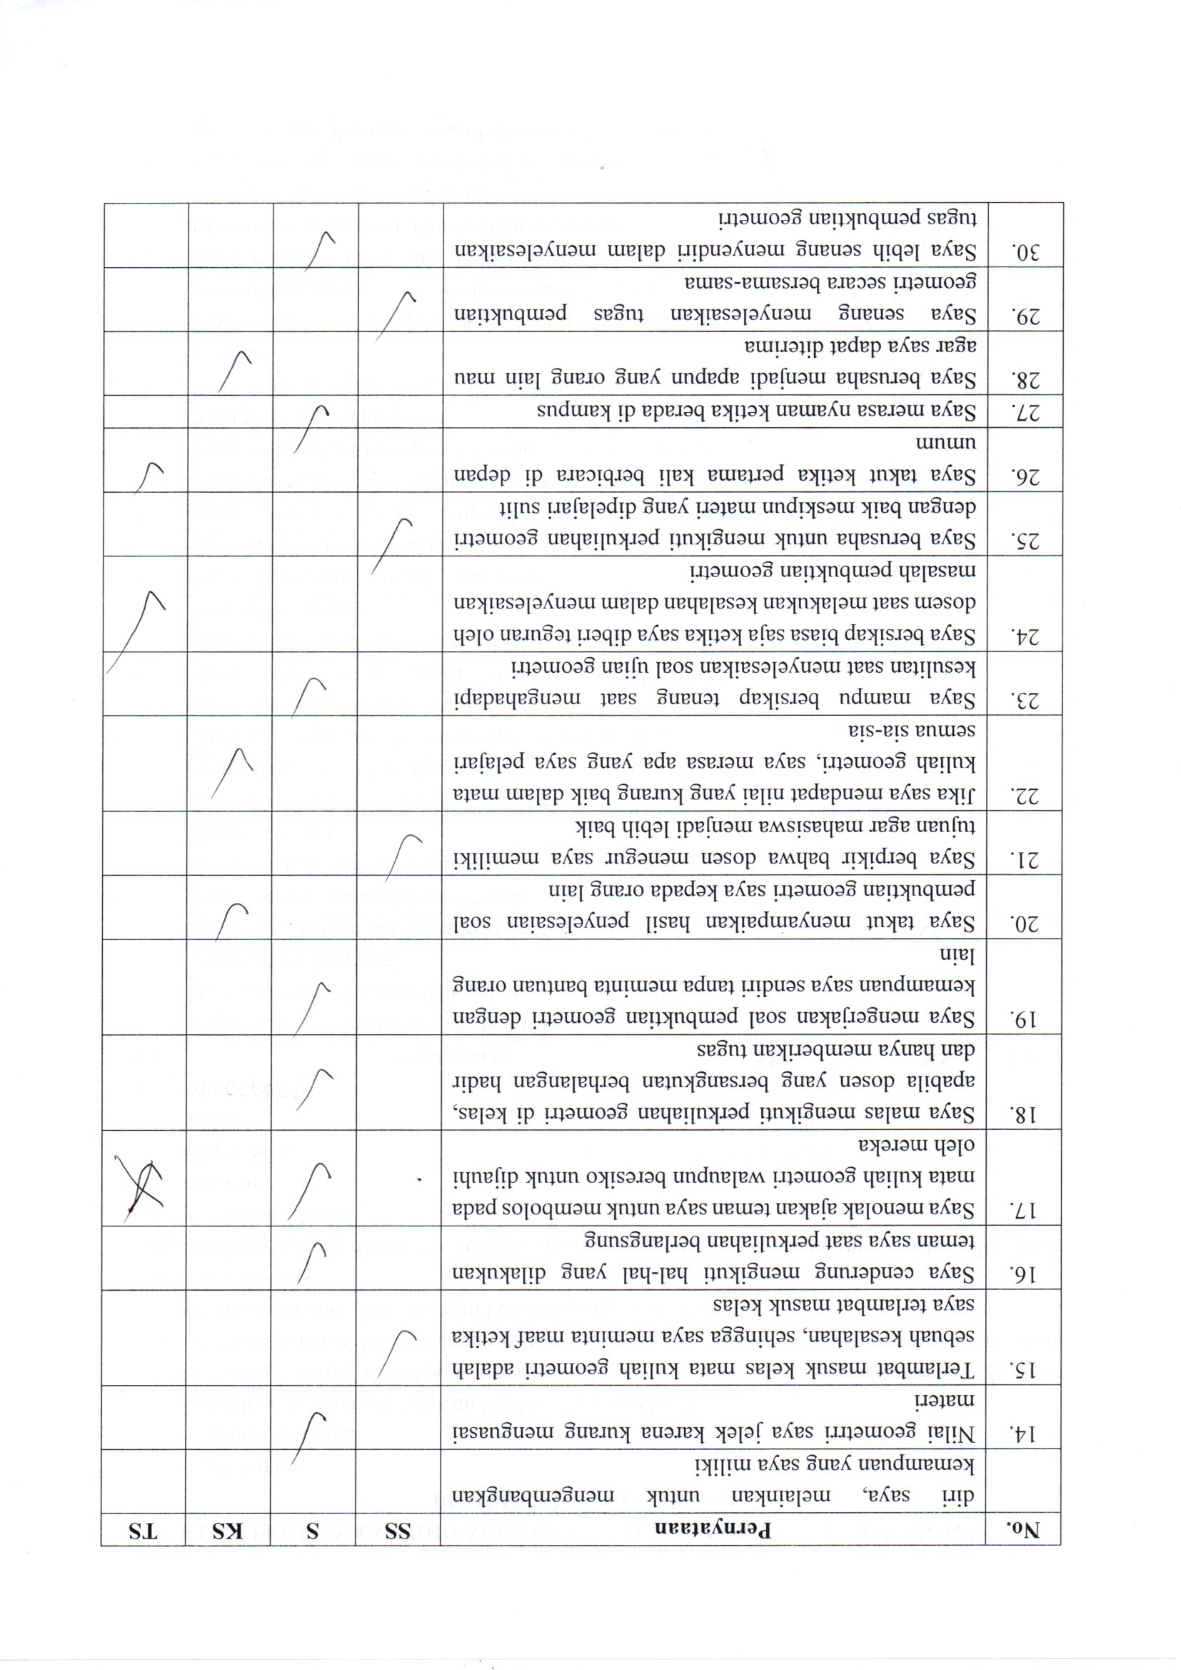

LAMPIRAN C
BUKTI OLAH DATA
C-1 HASIL SOAL UTS PEMBUKTIAN
C-2 HASIL ANGKET

C- 1 Hasil UTS Soal Pembuktian
NO | NAMA | NILAI UTS PEMBUKTIAN | KELOMPOK
1 | Adi Julianto Kusnadi | 76 | Tinggi
2 | Adinda Permata | 41 | Sedang
3 | Aditia Muhamad | 50 | Sedang
4 | Aditya Mohammad Iqbal | 25 | Rendah
5 | Afifah Aini Rahmah | 50 | Sedang
6 | Afifah Indah Pratiwi | 41 | Sedang
7 | Ainun Jariah | 36 | Sedang
8 | Aisyah Asma Karimah | 58 | Sedang
9 | Akbar Armanda | 26 | Rendah
10 | Akhmad Nurul Mutamam | 37 | Sedang
11 | Alfi Intan Pertiwi | 33 | Sedang
12 | Alia Afrilyanti | 26 | Rendah
13 | Alifia Azhari Rahman | 67 | Tinggi
14 | Aliya Arini Fadilah | 43 | Sedang
15 | Almuthliatul Azizah Rizki Bahari | 52 | Sedang
16 | Amelia Belinda | 62 | Tinggi
17 | Amelia Muhibatul Milah | 83 | Tinggi
18 | Andreani Puspitaningrum | 47 | Sedang
19 | Anisah Puspita Dewi | 43 | Sedang
20 | Annisa Eka F. H | 80 | Tinggi
21 | Annisa Fitria | 20 | Rendah
22 | Anugrah Agung Berliano | 60 | Tinggi
23 | Apsari Sabela | 31 | Sedang
24 | Aqsyal Ilham Syachbana | 86 | Tinggi
25 | Aryo Surya Wijaya | 36 | Sedang
26 | Athifah Rahardjo | 51 | Sedang
27 | Aulia Nursekha Salsabila | 55 | Sedang
28 | Aulia Putri Timur | 88 | Tinggi
29 | Ayu Ratna Komalasari | 46 | Sedang
30 | Dara Suci Munggaran | 66 | Tinggi
31 | Delianti Nurul Fazri | 67 | Tinggi
32 | Dera Diastari | 53 | Sedang
33 | Devi Permatasari | 18 | Rendah
34 | Dian Putri Romlah | 56 | Sedang
35 | Dilla Siti Halimah | 30 | Sedang
36 | Fachjriani Nur Destianti | 36 | Sedang
37 | Fadli Fathira | 95 | Tinggi
38 | Fairuz Salsabila | 25 | Rendah
39 | Fanny Fadlilatun nisa | 60 | Tinggi
40 | Faza Fadhilah Hayya Wijaya | 87 | Tinggi
41 | Febi Febrilianti Fajrin | 32 | Sedang
42 | Fella Nur Azizah | 70 | Tinggi
43 | burhan Fa |  | Rendah
44 | Hafidz Awaludin | 53 | Sedang
45 | Halwa Fudhilaallah Mahmudah Syah | 80 | Tinggi
46 | Hazar Miliki Hidayat | 40 | Sedang
47 | Hilma Fauziah | 23 | Rendah
48 | Hilmy Dwi Ismiranti | 17 | Rendah
49 | Hisar Asman Mirsa Harahap | 42 | Sedang
50 | Iis Robiatul Adawiyah | 27 | Rendah
51 | Ima Hafidzah Nurhalimah | 80 | Tinggi
52 | Imam Hasbulloh | 53 | Sedang
53 | Islah Nurul Fadillah | 25 | Rendah
54 | Kartika Amelia Cahyanti | 32 | Sedang
55 | Komalasari | 20 | Rendah
56 | Lutfia Dwi Jayanti | 57 | Sedang
57 | Luthfita Adrikni Suryani | 17 | Rendah
58 | Mahdiyah Luthfi | 30 | Sedang
59 | Maryam | 23 | Rendah
60 | Maulana Yusuf Agmalna Putra | 12 | Rendah
61 | Meidina Purnama Putri | 98 | Tinggi
62 | Moch Aldiansyah | 32 | Sedang
63 | Mochamad Faizal Backrie Essar | 23 | Rendah
64 | Muhamad Figur Naufal Hilmy | 28 | Rendah
65 | Muhammad Iqra Rabbani | 87 | Tinggi
66 | Muhammad Tandhimul Haq | 97 | Tinggi
67 | Muludin Rofik | 42 | Sedang
68 | Muna Rafika | 27 | Rendah
69 | Nabila Aryati | 30 | Sedang
70 | Nabila Dwi Utari | 37 | Sedang
71 | Nadia Rusdaini | 43 | Sedang
72 | Nathifa Zahwa Nasution | 50 | Sedang
73 | Naura Osza Ghinanti | 42 | Sedang
74 | Nova Srinovita | 18 | Rendah
75 | Nurhasanah | 20 | Rendah
76 | Nurul Ilmi Istiqomah | 23 | Rendah
77 | Permas Puspa Aryanti | 42 | Sedang
78 | Putri Ayunda Lestari | 43 | Sedang
79 | Putri khansa Nabilah | 30 | Sedang
80 | Putri Nur’aisyah | 42 | Sedang
81 | R.S. Shafira Himmatul Amal | 55 | Sedang
82 | Rahadian Nur Irfan Saepul | 58 | Sedang
83 | Rahma Siti Islamiati | 20 | Rendah
84 | Rana Rasyidah Rahmah | 53 | Sedang
85 | Resiya Putri Nurpathoni | 20 | Rendah
86 | Rifqi Syaeful Akbar | 61 | Tinggi
87 | Rihan Nada Tsaqila | 43 | Sedang
88 | Rijki Nuholih | 33 | Sedang
89 | Rindiani Nur Sifa Padila | 38 | Sedang
90 | Risa Kania Putri | 76 | Tinggi
91 | Riska Dwi Febriyanti | 61 | Tinggi
92 | Risma Normalasari | 93 | Tinggi
93 | Salda Dwi Fadya Ariesta | 55 | Sedang
94 | Salma Lisdiyana Nurfitriyah | 28 | Rendah
95 | Salsa Agustina | 21 | Rendah
96 | Sandi Muhammad Nopianto | 46 | Sedang
97 | Sarah Siti Fatimah | 71 | Tinggi
98 | Sayufi Atqia Putri | 45 | Sedang
99 | Sekar Purnami Wulan | 55 | Sedang
100 | Selly Safitri | 85 | Tinggi
101 | Shinta Angel Setiawati | 23 | Rendah
102 | Silvi Febrianti | 23 | Rendah
103 | Sintya Rahma Fadillha | 41 | Sedang
104 | Siti Fauziah Jamaludin | 41 | Sedang
105 | Siti Miftahurrohmah Khoirunisa | 76 | Tinggi
106 | Siti Taubatul Mudawamah | 35 | Sedang
107 | Siti Zahra Meydina Salsabila | 30 | Sedang
108 | Sri Asih Utami | 51 | Sedang
109 | Sri Lestari | 36 | Sedang
110 | Syifa Fauziah Widyana Putri | 60 | Tinggi
111 | Syifa Nurfitri | 61 | Tinggi
112 | Syifa Waliyatusshofiyyah | 88 | Tinggi
113 | Taufik Hidayat | 10 | Rendah
114 | Terra Meira Sukma Adya Sasongko | 33 | Sedang
115 | Toni Arinanto | 38 | Sedang
116 | Umi Nurhayati | 50 | Sedang
117 | Uzen Fauzi |  | Rendah
118 | Vania Febrina Ashari | 50 | Sedang
119 | Venya Dara Ramadhanti | 30 | Sedang
120 | Vina Alvia Nur Rahmah | 25 | Rendah
121 | Vista Ulya Azzahra | 93 | Tinggi
122 | Wulan Rismawanti D | 21 | Rendah
123 | Yayu Mutiara Hajar Efralia | 36 | Sedang
124 | Zalfaurrifdah Noor Salam | 60 | Tinggi
125 | Zulfa Ashilah Aziz | 56 | Sedang
126 | Zulfiyani Labib Abdillah | 58 | Sedang

C- 2 Hasil Angket
No | Kode | Pernyataan Ke-
No | Kode | 1 | 2 | 3 | 4 | 5 | 6 | 7 | 8 | 9 | 10 | 11 | 12 | 13 | 14 | 15
1 | A1 | 4 | 1 | 2 | 3 | 2 | 2 | 3 | 2 | 2 | 3 | 2 | 2 | 4 | 1 | 4
2 | A2 | 4 | 2 | 2 | 2 | 2 | 3 | 3 | 2 | 2 | 2 | 2 | 3 | 3 | 2 | 3
3 | A3 | 4 | 2 | 3 | 4 | 3 | 2 | 3 | 3 | 4 | 3 | 2 | 3 | 4 | 2 | 3
4 | A4 | 2 | 3 | 3 | 3 | 3 | 3 | 3 | 2 | 3 | 3 | 2 | 3 | 3 | 2 | 3
5 | A5 | 4 | 2 | 3 | 4 | 3 | 3 | 3 | 3 | 3 | 3 | 2 | 3 | 4 | 2 | 4
6 | A6 | 4 | 3 | 3 | 3 | 3 | 1 | 3 | 2 | 4 | 3 | 3 | 3 | 3 | 2 | 3
7 | A7 | 4 | 2 | 3 | 4 | 3 | 1 | 3 | 4 | 3 | 2 | 3 | 3 | 3 | 3 | 4
8 | A8 | 3 | 2 | 2 | 3 | 2 | 2 | 3 | 2 | 2 | 2 | 2 | 2 | 4 | 1 | 3
9 | A9 | 4 | 2 | 4 | 4 | 3 | 4 | 3 | 4 | 4 | 4 | 4 | 4 | 4 | 2 | 4
10 | A10 | 3 | 1 | 1 | 1 | 4 | 2 | 4 | 4 | 1 | 1 | 3 | 4 | 4 | 1 | 4
11 | A11 | 3 | 3 | 3 | 3 | 3 | 3 | 3 | 3 | 4 | 3 | 3 | 4 | 4 | 2 | 3
12 | A12 | 3 | 2 | 2 | 4 | 2 | 3 | 3 | 3 | 2 | 2 | 3 | 4 | 3 | 2 | 3
13 | A13 | 3 | 2 | 2 | 4 | 2 | 2 | 3 | 3 | 3 | 2 | 2 | 4 | 3 | 2 | 2
14 | A14 | 4 | 3 | 3 | 3 | 2 | 3 | 3 | 4 | 3 | 0 | 3 | 2 | 3 | 3 | 3
15 | A15 | 4 | 2 | 3 | 2 | 2 | 2 | 3 | 2 | 3 | 2 | 2 | 3 | 2 | 2 | 3
16 | A16 | 4 | 2 | 3 | 2 | 2 | 2 | 3 | 2 | 3 | 2 | 2 | 2 | 3 | 2 | 3
17 | A17 | 4 | 2 | 3 | 3 | 3 | 2 | 3 | 4 | 4 | 3 | 3 | 4 | 3 | 2 | 3
18 | A18 | 3 | 2 | 3 | 3 | 2 | 2 | 3 | 3 | 3 | 2 | 3 | 2 | 3 | 2 | 3
19 | A19 | 4 | 2 | 3 | 2 | 2 | 2 | 3 | 2 | 2 | 3 | 2 | 2 | 4 | 1 | 4
20 | A20 | 3 | 2 | 3 | 3 | 2 | 3 | 2 | 4 | 1 | 1 | 3 | 3 | 3 | 2 | 3
21 | A21 | 4 | 2 | 3 | 3 | 3 | 2 | 3 | 3 | 3 | 2 | 2 | 3 | 4 | 2 | 4
22 | A22 | 4 | 2 | 2 | 3 | 2 | 2 | 4 | 2 | 3 | 3 | 2 | 2 | 3 | 2 | 3
23 | A23 | 4 | 2 | 2 | 3 | 2 | 2 | 3 | 3 | 3 | 2 | 2 | 3 | 3 | 3 | 3
24 | A24 | 3 | 2 | 2 | 4 | 2 | 3 | 3 | 4 | 1 | 2 | 2 | 2 | 4 | 2 | 3
25 | A25 | 4 | 2 | 3 | 3 | 3 | 3 | 3 | 3 | 2 | 2 | 3 | 3 | 4 | 2 | 3
26 | A26 | 4 | 0 | 3 | 4 | 2 | 3 | 3 | 2 | 3 | 3 | 2 | 2 | 3 | 2 | 3
27 | A27 | 4 | 2 | 0 | 3 | 3 | 2 | 3 | 2 | 2 | 2 | 2 | 3 | 4 | 1 | 4
28 | A28 | 4 | 4 | 3 | 4 | 3 | 3 | 3 | 3 | 3 | 3 | 2 | 4 | 4 | 2 | 3
29 | A29 | 4 | 4 | 4 | 4 | 4 | 4 | 3 | 4 | 3 | 2 | 3 | 2 | 4 | 2 | 3
30 | A30 | 4 | 3 | 3 | 4 | 3 | 3 | 3 | 4 | 3 | 2 | 2 | 4 | 3 | 2 | 4
31 | A31 | 4 | 3 | 3 | 3 | 2 | 2 | 3 | 3 | 3 | 3 | 3 | 2 | 4 | 2 | 4
32 | A32 | 4 | 2 | 2 | 1 | 3 | 2 | 3 | 4 | 2 | 3 | 2 | 3 | 3 | 2 | 4
33 | A33 | 4 | 2 | 2 | 3 | 2 | 2 | 3 | 2 | 3 | 3 | 2 | 3 | 3 | 2 | 3
34 | A34 | 4 | 3 | 2 | 3 | 2 | 2 | 3 | 2 | 3 | 3 | 2 | 4 | 4 | 2 | 3
35 | A35 | 3 | 3 | 3 | 3 | 3 | 3 | 3 | 3 | 3 | 3 | 2 | 3 | 3 | 2 | 3
36 | A36 | 4 | 2 | 3 | 2 | 3 | 3 | 0 | 4 | 3 | 2 | 3 | 3 | 3 | 2 | 3
37 | A37 | 4 | 3 | 3 | 3 | 2 | 2 | 3 | 3 | 3 | 3 | 3 | 2 | 4 | 3 | 3
38 | A38 | 4 | 1 | 4 | 4 | 1 | 2 | 3 | 2 | 4 | 0 | 1 | 4 | 3 | 2 | 3
39 | A39 | 3 | 2 | 2 | 3 | 2 | 3 | 3 | 3 | 2 | 2 | 2 | 3 | 4 | 2 | 3
40 | A40 | 4 | 2 | 3 | 3 | 3 | 2 | 4 | 3 | 4 | 2 | 3 | 4 | 3 | 2 | 4
41 | A41 | 4 | 4 | 4 | 4 | 2 | 3 | 3 | 3 | 4 | 4 | 4 | 4 | 4 | 2 | 4
42 | A42 | 4 | 2 | 3 | 4 | 3 | 2 | 3 | 3 | 3 | 2 | 2 | 3 | 4 | 2 | 4
43 | A43 | 4 | 2 | 3 | 3 | 2 | 2 | 3 | 3 | 3 | 3 | 2 | 3 | 4 | 2 | 3
44 | A44 | 4 | 2 | 2 | 3 | 2 | 3 | 3 | 3 | 2 | 3 | 2 | 4 | 3 | 2 | 3
45 | A45 | 4 | 2 | 3 | 3 | 3 | 3 | 3 | 3 | 3 | 3 | 3 | 3 | 3 | 2 | 3
46 | A46 | 4 | 3 | 2 | 2 | 2 | 2 | 2 | 3 | 3 | 3 | 2 | 3 | 4 | 2 | 4
47 | A47 | 2 | 4 | 4 | 4 | 2 | 2 | 2 | 3 | 3 | 2 | 4 | 1 | 4 | 2 | 3
48 | A48 | 4 | 1 | 2 | 2 | 3 | 2 | 3 | 3 | 1 | 2 | 2 | 3 | 4 | 1 | 4
49 | A49 | 4 | 2 | 2 | 2 | 1 | 2 | 2 | 2 | 3 | 2 | 2 | 3 | 4 | 1 | 3
50 | A50 | 4 | 3 | 3 | 3 | 2 | 2 | 4 | 3 | 3 | 2 | 3 | 3 | 3 | 2 | 3
51 | A51 | 4 | 2 | 3 | 3 | 3 | 2 | 2 | 3 | 3 | 3 | 3 | 3 | 4 | 2 | 4
52 | A52 | 4 | 3 | 2 | 4 | 2 | 2 | 4 | 4 | 4 | 4 | 4 | 2 | 4 | 4 | 4
53 | A53 | 4 | 2 | 3 | 3 | 2 | 2 | 3 | 2 | 2 | 2 | 2 | 3 | 4 | 2 | 4
54 | A54 | 4 | 2 | 4 | 1 | 4 | 2 | 3 | 4 | 4 | 2 | 4 | 4 | 4 | 2 | 4
55 | A55 | 3 | 2 | 2 | 4 | 1 | 2 | 4 | 4 | 3 | 2 | 3 | 3 | 3 | 2 | 3
56 | A56 | 4 | 2 | 2 | 3 | 2 | 3 | 2 | 3 | 2 | 2 | 2 | 2 | 4 | 2 | 3
57 | A57 | 4 | 4 | 4 | 3 | 4 | 4 | 3 | 3 | 4 | 2 | 3 | 4 | 4 | 1 | 4
58 | A58 | 4 | 1 | 3 | 4 | 2 | 1 | 3 | 4 | 2 | 1 | 3 | 1 | 4 | 1 | 4
59 | A59 | 4 | 3 | 3 | 4 | 2 | 2 | 3 | 4 | 3 | 3 | 2 | 4 | 3 | 2 | 3
60 | A60 | 4 | 3 | 1 | 2 | 3 | 3 | 2 | 3 | 3 | 3 | 3 | 4 | 4 | 2 | 3
61 | A61 | 3 | 2 | 3 | 2 | 3 | 3 | 3 | 3 | 3 | 2 | 3 | 3 | 3 | 2 | 3
62 | A62 | 4 | 2 | 2 | 4 | 2 | 2 | 4 | 3 | 3 | 2 | 2 | 3 | 4 | 1 | 4
63 | A63 | 4 | 3 | 4 | 3 | 3 | 3 | 3 | 3 | 3 | 3 | 3 | 3 | 4 | 2 | 3
64 | A64 | 4 | 2 | 3 | 2 | 3 | 2 | 4 | 2 | 3 | 2 | 4 | 3 | 4 | 2 | 4
65 | A65 | 4 | 2 | 3 | 2 | 3 | 3 | 3 | 3 | 2 | 2 | 3 | 4 | 4 | 3 | 3
66 | A66 | 4 | 3 | 4 | 3 | 3 | 3 | 4 | 4 | 3 | 3 | 3 | 3 | 4 | 2 | 4
67 | A67 | 3 | 1 | 2 | 3 | 2 | 2 | 3 | 2 | 2 | 1 | 2 | 2 | 3 | 2 | 3
68 | A68 | 4 | 3 | 4 | 4 | 4 | 3 | 4 | 4 | 3 | 4 | 4 | 2 | 4 | 4 | 3
69 | A69 | 3 | 1 | 2 | 3 | 2 | 1 | 3 | 2 | 2 | 2 | 2 | 4 | 4 | 2 | 3
70 | A70 | 3 | 3 | 3 | 2 | 2 | 3 | 3 | 3 | 3 | 2 | 3 | 3 | 3 | 2 | 3
71 | A71 | 4 | 2 | 2 | 4 | 2 | 2 | 3 | 2 | 3 | 1 | 2 | 3 | 4 | 1 | 4
72 | A72 | 4 | 3 | 4 | 4 | 4 | 4 | 3 | 3 | 4 | 3 | 4 | 3 | 4 | 1 | 4
73 | A73 | 3 | 2 | 3 | 4 | 1 | 2 | 2 | 2 | 2 | 2 | 1 | 2 | 4 | 2 | 4
74 | A74 | 3 | 2 | 3 | 3 | 3 | 3 | 3 | 3 | 3 | 3 | 4 | 3 | 3 | 3 | 4
75 | A75 | 4 | 4 | 3 | 4 | 2 | 3 | 3 | 4 | 4 | 4 | 3 | 3 | 4 | 2 | 4
76 | A76 | 4 | 3 | 2 | 2 | 3 | 3 | 3 | 2 | 4 | 2 | 2 | 2 | 4 | 2 | 4
77 | A77 | 4 | 4 | 2 | 4 | 3 | 3 | 2 | 4 | 4 | 4 | 3 | 2 | 3 | 2 | 4
78 | A78 | 4 | 2 | 3 | 4 | 4 | 4 | 3 | 4 | 4 | 2 | 1 | 4 | 4 | 1 | 4
79 | A79 | 4 | 2 | 2 | 4 | 2 | 2 | 3 | 3 | 3 | 2 | 2 | 2 | 4 | 2 | 3
80 | A80 | 4 | 2 | 2 | 4 | 2 | 2 | 3 | 3 | 3 | 2 | 2 | 4 | 3 | 2 | 3
81 | A81 | 3 | 4 | 3 | 3 | 3 | 3 | 3 | 4 | 3 | 3 | 3 | 4 | 4 | 2 | 3
82 | A82 | 4 | 2 | 2 | 4 | 2 | 3 | 3 | 4 | 4 | 2 | 2 | 3 | 4 | 2 | 2
83 | A83 | 4 | 2 | 2 | 4 | 2 | 2 | 4 | 3 | 3 | 3 | 2 | 3 | 4 | 2 | 4
84 | A84 | 3 | 2 | 2 | 2 | 2 | 3 | 3 | 3 | 3 | 2 | 2 | 3 | 3 | 2 | 4
85 | A85 | 4 | 3 | 3 | 4 | 2 | 3 | 3 | 4 | 3 | 3 | 3 | 3 | 4 | 2 | 4
86 | A86 | 4 | 2 | 2 | 2 | 2 | 2 | 3 | 2 | 3 | 3 | 2 | 1 | 4 | 2 | 3
87 | A87 | 4 | 2 | 2 | 3 | 2 | 2 | 3 | 3 | 2 | 2 | 2 | 3 | 3 | 2 | 2
88 | A88 | 4 | 3 | 3 | 4 | 2 | 2 | 4 | 3 | 4 | 3 | 3 | 3 | 4 | 1 | 4
89 | A89 | 4 | 3 | 3 | 1 | 3 | 2 | 4 | 2 | 3 | 3 | 3 | 3 | 4 | 1 | 4
90 | A90 | 4 | 2 | 2 | 3 | 2 | 1 | 3 | 3 | 4 | 3 | 3 | 3 | 4 | 2 | 4
91 | A91 | 4 | 2 | 4 | 3 | 3 | 3 | 3 | 3 | 4 | 4 | 2 | 3 | 4 | 3 | 4
92 | A92 | 4 | 2 | 2 | 4 | 2 | 3 | 3 | 3 | 3 | 3 | 2 | 2 | 4 | 2 | 3
93 | A93 | 4 | 4 | 2 | 4 | 2 | 3 | 3 | 4 | 3 | 3 | 3 | 3 | 3 | 3 | 3
94 | A94 | 4 | 3 | 2 | 4 | 2 | 3 | 3 | 4 | 4 | 2 | 2 | 3 | 4 | 3 | 4
95 | A95 | 3 | 2 | 2 | 2 | 3 | 3 | 3 | 3 | 2 | 2 | 3 | 3 | 3 | 2 | 2
96 | A96 | 4 | 1 | 1 | 4 | 1 | 2 | 4 | 3 | 1 | 1 | 1 | 3 | 4 | 1 | 4
97 | A97 | 3 | 1 | 2 | 3 | 2 | 1 | 3 | 2 | 2 | 2 | 2 | 4 | 4 | 2 | 3
98 | A98 | 3 | 3 | 3 | 2 | 2 | 3 | 3 | 3 | 3 | 2 | 3 | 3 | 3 | 2 | 3
99 | A99 | 4 | 2 | 2 | 4 | 2 | 2 | 3 | 2 | 3 | 1 | 2 | 3 | 4 | 1 | 4
94 | A94 | 4 | 3 | 4 | 4 | 4 | 4 | 3 | 3 | 4 | 3 | 4 | 3 | 4 | 1 | 4
95 | A95 | 3 | 2 | 3 | 4 | 1 | 2 | 2 | 2 | 2 | 2 | 1 | 2 | 4 | 2 | 4
96 | A96 | 3 | 2 | 3 | 3 | 3 | 3 | 3 | 3 | 3 | 3 | 4 | 3 | 3 | 3 | 4
97 | A97 | 4 | 2 | 1 | 3 | 1 | 1 | 3 | 1 | 3 | 1 | 1 | 4 | 4 | 2 | 4
98 | A98 | 4 | 2 | 2 | 3 | 2 | 2 | 4 | 4 | 4 | 1 | 3 | 4 | 4 | 2 | 4
99 | A99 | 4 | 4 | 3 | 4 | 3 | 4 | 3 | 4 | 4 | 4 | 3 | 4 | 4 | 2 | 4
100 | A100 | 3 | 3 | 3 | 3 | 2 | 2 | 3 | 3 | 3 | 3 | 2 | 3 | 4 | 2 | 4
101 | A101 | 4 | 2 | 3 | 4 | 3 | 2 | 3 | 4 | 4 | 3 | 3 | 3 | 3 | 1 | 4
102 | A102 | 4 | 2 | 2 | 4 | 2 | 2 | 3 | 2 | 3 | 2 | 3 | 3 | 4 | 2 | 4
103 | A103 | 4 | 4 | 4 | 3 | 4 | 3 | 3 | 3 | 4 | 3 | 3 | 3 | 4 | 4 | 3
104 | A104 | 3 | 3 | 3 | 3 | 3 | 2 | 2 | 2 | 3 | 3 | 2 | 3 | 3 | 2 | 3
105 | A105 | 4 | 3 | 3 | 2 | 3 | 3 | 3 | 3 | 4 | 3 | 3 | 3 | 4 | 2 | 4
106 | A106 | 3 | 2 | 3 | 3 | 3 | 2 | 3 | 3 | 3 | 2 | 2 | 3 | 3 | 2 | 3
107 | A107 | 4 | 2 | 3 | 3 | 2 | 2 | 4 | 4 | 4 | 4 | 3 | 2 | 4 | 1 | 4
108 | A108 | 3 | 4 | 4 | 3 | 4 | 4 | 3 | 4 | 3 | 4 | 3 | 3 | 3 | 2 | 4
109 | A109 | 4 | 3 | 3 | 2 | 3 | 4 | 3 | 3 | 2 | 3 | 3 | 4 | 4 | 1 | 4
110 | A110 | 4 | 2 | 2 | 1 | 1 | 2 | 4 | 3 | 3 | 2 | 2 | 2 | 4 | 2 | 4
111 | A111 | 4 | 3 | 2 | 4 | 2 | 1 | 3 | 2 | 3 | 3 | 3 | 3 | 4 | 2 | 4
Jumlah |  | 416 | 265 | 295 | 345 | 273 | 272 | 337 | 335 | 330 | 274 | 281 | 329 | 403 | 218 | 383
Rata-rata |  | 3.82 | 2.43 | 2.71 | 3.17 | 2.50 | 2.50 | 3.09 | 3.07 | 3.03 | 2.51 | 2.58 | 3.02 | 3.70 | 2.00 | 3.51

No | Kode | Penyataan Ke- |  |  |  |  |  |  |  |  |  |  |  |  |  |  | Jml
No | Kode | 16 | 17 | 18 | 19 | 20 | 21 | 22 | 23 | 24 | 25 | 26 | 27 | 28 | 29 | 30 | Jml
1 | A1 | 3 | 4 | 3 | 2 | 1 | 4 | 3 | 2 | 4 | 3 | 1 | 2 | 4 | 3 | 3 | 79
2 | A2 | 3 | 3 | 2 | 3 | 2 | 4 | 2 | 3 | 3 | 4 | 3 | 2 | 3 | 3 | 3 | 80
3 | A3 | 4 | 4 | 4 | 2 | 2 | 4 | 4 | 2 | 4 | 4 | 2 | 2 | 2 | 4 | 4 | 93
4 | A4 | 2 | 3 | 3 | 2 | 3 | 3 | 2 | 3 | 2 | 3 | 3 | 3 | 3 | 3 | 3 | 82
5 | A5 | 3 | 4 | 3 | 4 | 3 | 4 | 3 | 3 | 2 | 4 | 3 | 3 | 3 | 3 | 3 | 94
6 | A6 | 2 | 4 | 2 | 2 | 2 | 4 | 4 | 3 | 3 | 4 | 1 | 3 | 3 | 4 | 3 | 87
7 | A7 | 3 | 4 | 3 | 2 | 1 | 4 | 3 | 2 | 4 | 4 | 2 | 3 | 3 | 4 | 3 | 90
8 | A8 | 2 | 4 | 1 | 3 | 2 | 4 | 4 | 2 | 3 | 3 | 2 | 2 | 3 | 3 | 2 | 75
9 | A9 | 4 | 4 | 4 | 4 | 4 | 4 | 2 | 3 | 4 | 4 | 0 | 3 | 1 | 4 | 3 | 102
10 | A10 | 4 | 4 | 1 | 2 | 1 | 4 | 1 | 1 | 4 | 3 | 4 | 1 | 3 | 4 | 4 | 79
11 | A11 | 4 | 1 | 2 | 3 | 3 | 3 | 3 | 3 | 4 | 4 | 4 | 3 | 4 | 3 | 3 | 94
12 | A12 | 3 | 3 | 4 | 2 | 3 | 3 | 3 | 2 | 2 | 3 | 3 | 3 | 3 | 3 | 3 | 84
13 | A13 | 4 | 3 | 3 | 2 | 4 | 3 | 4 | 3 | 3 | 3 | 3 | 2 | 4 | 3 | 3 | 86
14 | A14 | 2 | 1 | 4 | 2 | 2 | 3 | 3 | 3 | 3 | 4 | 3 | 3 | 1 | 4 | 3 | 83
15 | A15 | 2 | 3 | 4 | 3 | 2 | 3 | 2 | 3 | 2 | 3 | 3 | 3 | 3 | 3 | 3 | 79
16 | A16 | 2 | 3 | 4 | 3 | 2 | 3 | 2 | 3 | 2 | 3 | 3 | 3 | 3 | 3 | 3 | 79
17 | A17 | 2 | 4 | 3 | 3 | 2 | 4 | 3 | 3 | 4 | 3 | 2 | 3 | 2 | 4 | 4 | 92
18 | A18 | 2 | 3 | 2 | 2 | 2 | 3 | 3 | 3 | 3 | 3 | 2 | 3 | 2 | 4 | 3 | 79
19 | A19 | 3 | 4 | 4 | 2 | 2 | 4 | 3 | 4 | 3 | 4 | 1 | 3 | 3 | 4 | 4 | 86
20 | A20 | 2 | 3 | 3 | 2 | 3 | 4 | 1 | 2 | 4 | 4 | 4 | 3 | 1 | 3 | 4 | 81
21 | A21 | 3 | 4 | 2 | 3 | 2 | 4 | 3 | 3 | 3 | 4 | 2 | 3 | 2 | 3 | 3 | 87
22 | A22 | 3 | 4 | 2 | 2 | 2 | 4 | 3 | 3 | 3 | 3 | 2 | 3 | 3 | 4 | 3 | 83
23 | A23 | 3 | 3 | 3 | 3 | 2 | 3 | 2 | 2 | 3 | 3 | 3 | 3 | 3 | 3 | 3 | 82
24 | A24 | 3 | 4 | 2 | 2 | 2 | 3 | 2 | 3 | 3 | 4 | 3 | 2 | 2 | 3 | 3 | 80
25 | A25 | 3 | 3 | 3 | 3 | 3 | 3 | 3 | 3 | 2 | 4 | 2 | 3 | 3 | 4 | 3 | 88
26 | A26 | 3 | 4 | 2 | 2 | 2 | 3 | 4 | 2 | 3 | 3 | 3 | 3 | 4 | 3 | 3 | 83
27 | A27 | 3 | 4 | 2 | 3 | 3 | 4 | 3 | 3 | 2 | 4 | 2 | 4 | 3 | 4 | 4 | 85
28 | A28 | 3 | 3 | 3 | 1 | 3 | 4 | 4 | 3 | 4 | 3 | 4 | 3 | 3 | 3 | 2 | 94
29 | A29 | 3 | 4 | 3 | 4 | 3 | 3 | 4 | 3 | 3 | 3 | 3 | 3 | 1 | 4 | 3 | 97
30 | A30 | 3 | 4 | 2 | 3 | 3 | 4 | 2 | 2 | 3 | 3 | 2 | 3 | 3 | 3 | 2 | 89
31 | A31 | 3 | 4 | 3 | 2 | 3 | 4 | 4 | 2 | 2 | 4 | 1 | 4 | 4 | 4 | 3 | 91
32 | A32 | 4 | 4 | 4 | 3 | 3 | 4 | 2 | 2 | 2 | 4 | 2 | 3 | 2 | 4 | 4 | 87
33 | A33 | 3 | 4 | 3 | 2 | 2 | 3 | 3 | 3 | 3 | 3 | 2 | 2 | 3 | 3 | 3 | 81
34 | A34 | 0 | 3 | 4 | 2 | 2 | 3 | 3 | 1 | 4 | 3 | 2 | 3 | 4 | 3 | 2 | 81
35 | A35 | 3 | 3 | 4 | 3 | 2 | 3 | 3 | 3 | 3 | 4 | 3 | 3 | 3 | 3 | 3 | 89
36 | A36 | 3 | 3 | 4 | 3 | 3 | 3 | 3 | 3 | 3 | 3 | 2 | 3 | 3 | 3 | 2 | 84
37 | A37 | 3 | 4 | 3 | 3 | 3 | 4 | 3 | 3 | 4 | 3 | 3 | 3 | 3 | 3 | 3 | 92
38 | A38 | 2 | 3 | 2 | 1 | 2 | 4 | 1 | 3 | 2 | 4 | 1 | 2 | 3 | 4 | 3 | 75
39 | A39 | 3 | 3 | 3 | 3 | 2 | 4 | 3 | 3 | 3 | 4 | 2 | 2 | 3 | 4 | 3 | 84
40 | A40 | 3 | 3 | 3 | 3 | 2 | 4 | 2 | 3 | 4 | 3 | 2 | 3 | 3 | 3 | 3 | 90
41 | A41 | 3 | 1 | 3 | 2 | 3 | 4 | 4 | 2 | 2 | 3 | 2 | 3 | 3 | 4 | 3 | 95
42 | A42 | 3 | 4 | 2 | 2 | 3 | 4 | 4 | 2 | 3 | 4 | 3 | 3 | 3 | 3 | 3 | 90
43 | A43 | 3 | 3 | 3 | 3 | 2 | 3 | 3 | 2 | 2 | 3 | 3 | 3 | 3 | 3 | 2 | 83
44 | A44 | 3 | 3 | 3 | 2 | 3 | 3 | 3 | 3 | 3 | 4 | 2 | 3 | 4 | 3 | 3 | 86
45 | A45 | 2 | 4 | 2 | 3 | 3 | 4 | 3 | 4 | 3 | 4 | 3 | 3 | 3 | 4 | 2 | 91
46 | A46 | 3 | 4 | 4 | 2 | 2 | 4 | 3 | 3 | 3 | 4 | 2 | 3 | 2 | 4 | 3 | 87
47 | A47 | 3 | 4 | 3 | 3 | 4 | 4 | 4 | 4 | 3 | 4 | 1 | 4 | 4 | 4 | 1 | 92
48 | A48 | 3 | 4 | 4 | 4 | 2 | 4 | 4 | 4 | 3 | 4 | 2 | 3 | 3 | 4 | 4 | 89
49 | A49 | 4 | 4 | 2 | 2 | 2 | 4 | 4 | 1 | 4 | 4 | 1 | 3 | 3 | 3 | 3 | 79
50 | A50 | 3 | 3 | 2 | 2 | 3 | 4 | 3 | 3 | 4 | 3 | 2 | 3 | 2 | 3 | 3 | 86
51 | A51 | 3 | 4 | 3 | 2 | 3 | 4 | 4 | 4 | 3 | 4 | 2 | 2 | 3 | 4 | 3 | 92
52 | A52 | 2 | 4 | 4 | 2 | 2 | 4 | 4 | 4 | 3 | 4 | 2 | 4 | 3 | 3 | 1 | 97
53 | A53 | 3 | 3 | 3 | 2 | 2 | 4 | 3 | 2 | 2 | 3 | 2 | 3 | 3 | 3 | 3 | 81
54 | A54 | 3 | 4 | 3 | 3 | 4 | 4 | 4 | 2 | 4 | 4 | 4 | 3 | 3 | 4 | 3 | 100
55 | A55 | 4 | 4 | 3 | 2 | 2 | 4 | 4 | 1 | 4 | 4 | 2 | 3 | 3 | 3 | 2 | 86
56 | A56 | 2 | 3 | 2 | 2 | 2 | 4 | 3 | 4 | 3 | 4 | 3 | 3 | 2 | 3 | 3 | 81
57 | A57 | 3 | 4 | 4 | 3 | 4 | 4 | 2 | 2 | 3 | 3 | 3 | 0 | 3 | 3 | 3 | 95
58 | A58 | 3 | 4 | 3 | 3 | 1 | 4 | 4 | 1 | 4 | 4 | 1 | 3 | 3 | 4 | 4 | 84
59 | A59 | 3 | 4 | 4 | 3 | 3 | 4 | 3 | 3 | 3 | 4 | 3 | 3 | 3 | 3 | 3 | 94
60 | A60 | 4 | 4 | 3 | 3 | 2 | 4 | 1 | 3 | 4 | 4 | 4 | 3 | 3 | 3 | 2 | 90
61 | A61 | 3 | 4 | 3 | 2 | 3 | 3 | 2 | 3 | 3 | 4 | 3 | 3 | 3 | 3 | 2 | 85
62 | A62 | 3 | 4 | 4 | 2 | 2 | 4 | 4 | 2 | 4 | 3 | 2 | 3 | 3 | 4 | 3 | 89
63 | A63 | 2 | 4 | 2 | 3 | 3 | 4 | 2 | 2 | 4 | 3 | 2 | 2 | 2 | 1 | 1 | 84
64 | A64 | 3 | 4 | 3 | 3 | 2 | 4 | 4 | 3 | 3 | 4 | 2 | 3 | 4 | 4 | 2 | 92
65 | A65 | 3 | 4 | 3 | 4 | 3 | 4 | 4 | 2 | 3 | 4 | 3 | 4 | 3 | 3 | 2 | 93
66 | A66 | 3 | 4 | 4 | 3 | 3 | 4 | 3 | 3 | 3 | 4 | 4 | 3 | 3 | 2 | 1 | 97
67 | A67 | 1 | 4 | 4 | 3 | 2 | 3 | 3 | 3 | 3 | 4 | 3 | 4 | 3 | 4 | 3 | 80
68 | A68 | 3 | 4 | 4 | 4 | 3 | 3 | 3 | 3 | 4 | 3 | 2 | 4 | 2 | 3 | 1 | 100
69 | A69 | 2 | 3 | 1 | 3 | 1 | 4 | 3 | 4 | 3 | 4 | 1 | 2 | 1 | 4 | 4 | 76
70 | A70 | 2 | 3 | 3 | 3 | 3 | 3 | 3 | 2 | 2 | 3 | 2 | 3 | 3 | 3 | 2 | 81
71 | A71 | 3 | 4 | 3 | 2 | 2 | 4 | 4 | 3 | 2 | 4 | 1 | 4 | 3 | 4 | 4 | 86
72 | A72 | 3 | 4 | 2 | 3 | 3 | 4 | 3 | 2 | 2 | 4 | 2 | 2 | 3 | 2 | 2 | 93
73 | A73 | 1 | 4 | 1 | 2 | 2 | 4 | 3 | 2 | 4 | 4 | 1 | 3 | 1 | 4 | 4 | 76
74 | A74 | 3 | 4 | 3 | 2 | 2 | 3 | 4 | 3 | 3 | 4 | 3 | 4 | 3 | 4 | 2 | 93
75 | A75 | 3 | 4 | 3 | 2 | 4 | 3 | 4 | 4 | 3 | 3 | 4 | 3 | 3 | 4 | 4 | 102
76 | A76 | 3 | 4 | 4 | 2 | 2 | 3 | 3 | 1 | 3 | 4 | 2 | 3 | 3 | 3 | 3 | 85
77 | A77 | 2 | 4 | 2 | 3 | 3 | 4 | 4 | 3 | 4 | 3 | 1 | 4 | 3 | 3 | 3 | 94
78 | A78 | 4 | 4 | 4 | 2 | 4 | 4 | 3 | 4 | 2 | 4 | 1 | 3 | 3 | 4 | 3 | 97
79 | A79 | 3 | 3 | 3 | 2 | 2 | 3 | 3 | 3 | 3 | 3 | 2 | 3 | 4 | 3 | 2 | 82
80 | A80 | 3 | 3 | 3 | 2 | 3 | 3 | 3 | 3 | 4 | 3 | 3 | 2 | 3 | 3 | 3 | 85
81 | A81 | 4 | 4 | 2 | 2 | 4 | 4 | 4 | 3 | 4 | 4 | 2 | 3 | 4 | 3 | 1 | 96
82 | A82 | 3 | 3 | 4 | 3 | 2 | 4 | 3 | 3 | 3 | 4 | 3 | 3 | 3 | 3 | 3 | 90
83 | A83 | 3 | 4 | 3 | 2 | 3 | 4 | 3 | 3 | 3 | 3 | 2 | 3 | 3 | 4 | 4 | 91
84 | A84 | 3 | 4 | 3 | 3 | 2 | 4 | 4 | 2 | 3 | 3 | 2 | 3 | 4 | 3 | 2 | 84
85 | A85 | 3 | 4 | 3 | 3 | 3 | 4 | 4 | 3 | 3 | 4 | 4 | 3 | 2 | 3 | 3 | 97
86 | A86 | 3 | 3 | 4 | 2 | 2 | 4 | 3 | 2 | 4 | 4 | 3 | 3 | 3 | 3 | 3 | 83
87 | A87 | 3 | 4 | 3 | 3 | 2 | 4 | 3 | 2 | 2 | 4 | 3 | 3 | 3 | 3 | 3 | 82
88 | A88 | 4 | 4 | 4 | 2 | 4 | 4 | 4 | 4 | 1 | 4 | 4 | 4 | 4 | 4 | 4 | 102
89 | A89 | 3 | 4 | 2 | 2 | 3 | 3 | 2 | 3 | 2 | 4 | 3 | 3 | 3 | 2 | 1 | 83
90 | A90 | 3 | 3 | 3 | 3 | 2 | 4 | 3 | 2 | 3 | 4 | 1 | 3 | 3 | 3 | 3 | 86
91 | A91 | 2 | 4 | 3 | 3 | 2 | 4 | 4 | 3 | 3 | 4 | 3 | 2 | 4 | 3 | 3 | 96
92 | A92 | 3 | 4 | 3 | 3 | 2 | 3 | 3 | 3 | 3 | 3 | 3 | 3 | 3 | 3 | 3 | 87
93 | A93 | 3 | 3 | 4 | 3 | 3 | 3 | 3 | 3 | 4 | 3 | 3 | 3 | 3 | 3 | 1 | 92
94 | A94 | 2 | 4 | 4 | 3 | 2 | 4 | 4 | 4 | 4 | 3 | 2 | 3 | 1 | 4 | 4 | 95
95 | A95 | 3 | 3 | 2 | 3 | 3 | 3 | 2 | 2 | 3 | 3 | 2 | 1 | 3 | 2 | 3 | 76
96 | A96 | 3 | 4 | 4 | 3 | 2 | 4 | 3 | 2 | 4 | 4 | 2 | 1 | 4 | 3 | 1 | 79
97 | A97 | 2 | 3 | 1 | 3 | 1 | 4 | 3 | 4 | 3 | 4 | 1 | 2 | 1 | 4 | 4 | 76
98 | A98 | 2 | 3 | 3 | 3 | 3 | 3 | 3 | 2 | 2 | 3 | 2 | 3 | 3 | 3 | 2 | 81
99 | A99 | 3 | 4 | 3 | 2 | 2 | 4 | 4 | 3 | 2 | 4 | 1 | 4 | 3 | 4 | 4 | 86
94 | A94 | 3 | 4 | 2 | 3 | 3 | 4 | 3 | 2 | 2 | 4 | 2 | 2 | 3 | 2 | 2 | 93
95 | A95 | 1 | 4 | 1 | 2 | 2 | 4 | 3 | 2 | 4 | 4 | 1 | 3 | 1 | 4 | 4 | 76
96 | A96 | 3 | 4 | 3 | 2 | 2 | 3 | 4 | 3 | 3 | 4 | 3 | 4 | 3 | 4 | 2 | 93
97 | A97 | 2 | 4 | 4 | 4 | 1 | 4 | 4 | 4 | 3 | 4 | 2 | 3 | 3 | 2 | 2 | 81
98 | A98 | 3 | 4 | 3 | 2 | 2 | 4 | 2 | 2 | 4 | 3 | 3 | 3 | 3 | 4 | 4 | 91
99 | A99 | 3 | 4 | 3 | 4 | 3 | 4 | 4 | 3 | 3 | 4 | 2 | 3 | 3 | 2 | 2 | 101
100 | A100 | 3 | 4 | 3 | 2 | 3 | 4 | 3 | 3 | 3 | 3 | 1 | 3 | 3 | 4 | 3 | 88
101 | A101 | 3 | 1 | 2 | 2 | 2 | 4 | 3 | 3 | 2 | 3 | 3 | 3 | 4 | 4 | 3 | 88
102 | A102 | 2 | 4 | 1 | 2 | 2 | 3 | 3 | 2 | 3 | 3 | 2 | 3 | 3 | 4 | 3 | 82
103 | A103 | 2 | 3 | 3 | 4 | 3 | 4 | 4 | 4 | 3 | 4 | 4 | 3 | 3 | 4 | 2 | 102
104 | A104 | 3 | 4 | 3 | 2 | 3 | 3 | 3 | 3 | 3 | 3 | 3 | 3 | 4 | 4 | 4 | 88
105 | A105 | 2 | 3 | 2 | 3 | 3 | 4 | 3 | 3 | 4 | 4 | 4 | 3 | 3 | 4 | 2 | 94
106 | A106 | 2 | 3 | 3 | 2 | 2 | 3 | 2 | 3 | 3 | 3 | 2 | 3 | 3 | 3 | 3 | 80
107 | A107 | 2 | 4 | 3 | 4 | 4 | 4 | 4 | 4 | 4 | 4 | 1 | 4 | 2 | 4 | 3 | 97
108 | A108 | 2 | 3 | 3 | 2 | 2 | 4 | 4 | 3 | 4 | 3 | 3 | 3 | 3 | 3 | 3 | 96
109 | A109 | 3 | 4 | 4 | 2 | 3 | 4 | 3 | 2 | 3 | 4 | 4 | 4 | 3 | 4 | 4 | 97
110 | A110 | 3 | 4 | 2 | 2 | 3 | 4 | 4 | 3 | 3 | 4 | 2 | 2 | 2 | 4 | 3 | 83
111 | A111 | 2 | 4 | 4 | 4 | 2 | 4 | 4 | 3 | 2 | 4 | 2 | 3 | 3 | 4 | 1 | 89
Jumlah |  | 311 | 397 | 329 | 287 | 278 | 409 | 346 | 304 | 343 | 397 | 266 | 321 | 322 | 373 | 311
Rata-rata |  | 2.85 | 3.64 | 3.02 | 2.63 | 2.55 | 3.75 | 3.17 | 2.79 | 3.15 | 3.64 | 2.44 | 2.94 | 2.95 | 3.42 | 2.85

No. | Aspek yang Diukur | Penyataan Ke- | Skor Rata-rata Pernyataan ($\overline{X}$) | Skor Rata-rata Aspek
1. | Mahasiswa mempunyai keyakinan akan kemampuan diri | 1 | 3,75 | 2,84
1. | Mahasiswa mempunyai keyakinan akan kemampuan diri | 2 | 2,43 | 2,84
1. | Mahasiswa mempunyai keyakinan akan kemampuan diri | 3 | 2,71 | 2,84
1. | Mahasiswa mempunyai keyakinan akan kemampuan diri | 4 | 3,17 | 2,84
1. | Mahasiswa mempunyai keyakinan akan kemampuan diri | 5 | 2,50 | 2,84
1. | Mahasiswa mempunyai keyakinan akan kemampuan diri | 6 | 2,50 | 2,84
2. | Mahasiswa mempunyai sikap optimis | 7 | 3,04 | 2,83
2. | Mahasiswa mempunyai sikap optimis | 8 | 3,02 | 2,83
2. | Mahasiswa mempunyai sikap optimis | 9 | 2,97 | 2,83
2. | Mahasiswa mempunyai sikap optimis | 10 | 2,47 | 2,83
2. | Mahasiswa mempunyai sikap optimis | 11 | 2,53 | 2,83
2. | Mahasiswa mempunyai sikap optimis | 12 | 2,96 | 2,83
3. | Mahasiswa mempunyai sikap objektif | 13 | 3,63 | 2,96
3. | Mahasiswa mempunyai sikap objektif | 14 | 1,96 | 2,96
3. | Mahasiswa mempunyai sikap objektif | 15 | 3,45 | 2,96
3. | Mahasiswa mempunyai sikap objektif | 16 | 2,80 | 2,96
4. | Mahasiswa mempunyai sikap tanggungjawab | 17 | 3,58 | 2,91
4. | Mahasiswa mempunyai sikap tanggungjawab | 18 | 2,96 | 2,91
4. | Mahasiswa mempunyai sikap tanggungjawab | 19 | 2,59 | 2,91
4. | Mahasiswa mempunyai sikap tanggungjawab | 20 | 2,50 | 2,91
5. | Mahasiswa mempunyai sikp rasional | 21 | 3,68 | 3,16
5. | Mahasiswa mempunyai sikp rasional | 22 | 3,12 | 3,16
5. | Mahasiswa mempunyai sikp rasional | 23 | 2,74 | 3,16
5. | Mahasiswa mempunyai sikp rasional | 24 | 3,09 | 3,16
6. | Mahasiswa berani mencoba hal baru tanpa rasa takut | 25 | 3,58 | 2,99
6. | Mahasiswa berani mencoba hal baru tanpa rasa takut | 26 | 2,40 | 2,99
7. | Mahasiswa merasa dapat diterima oleh lingkungan tempat berinteraksi | 27 | 2,89 | 2,99
7. |  | 28 | 2,90 | 2,99
7. |  | 29 | 3,36 | 2,99
7. |  | 30 | 2,80 | 2,99

LAMPIRAN D
DOKUMENTASI
D-1 SURAT IZIN PENELITIAN
D-2 SOAL UAS
D-3 SOAL UTS
D-4 SOAL KUIS

D- 1 Surat Izin Penelitian
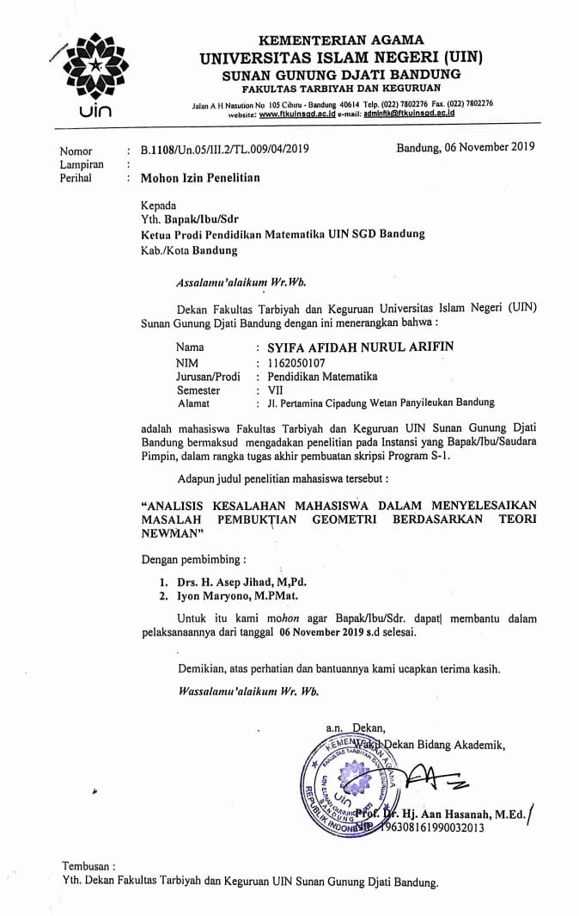
D- 2 Soal UAS
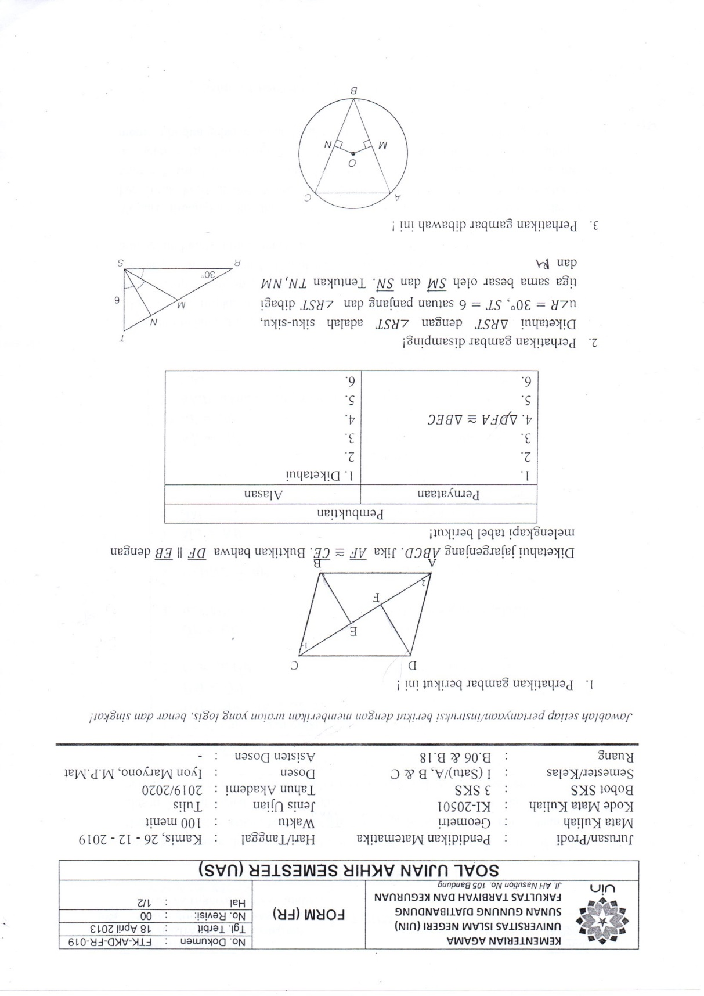

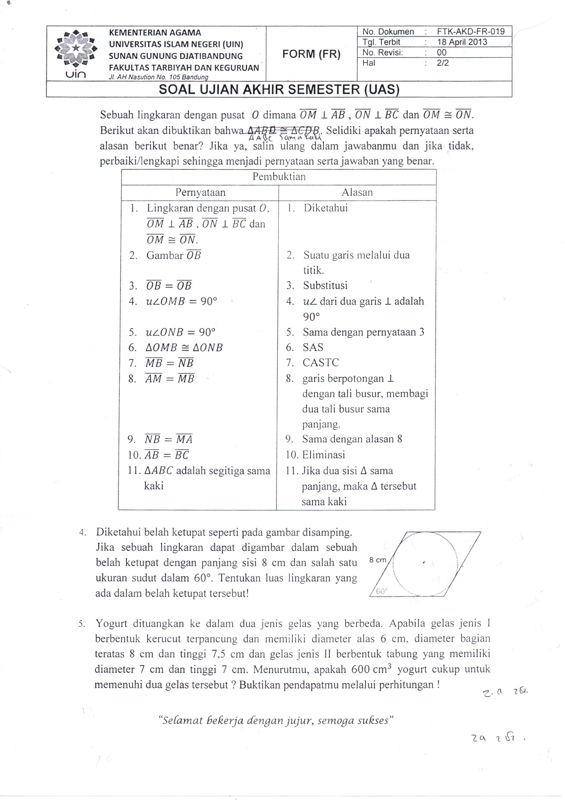

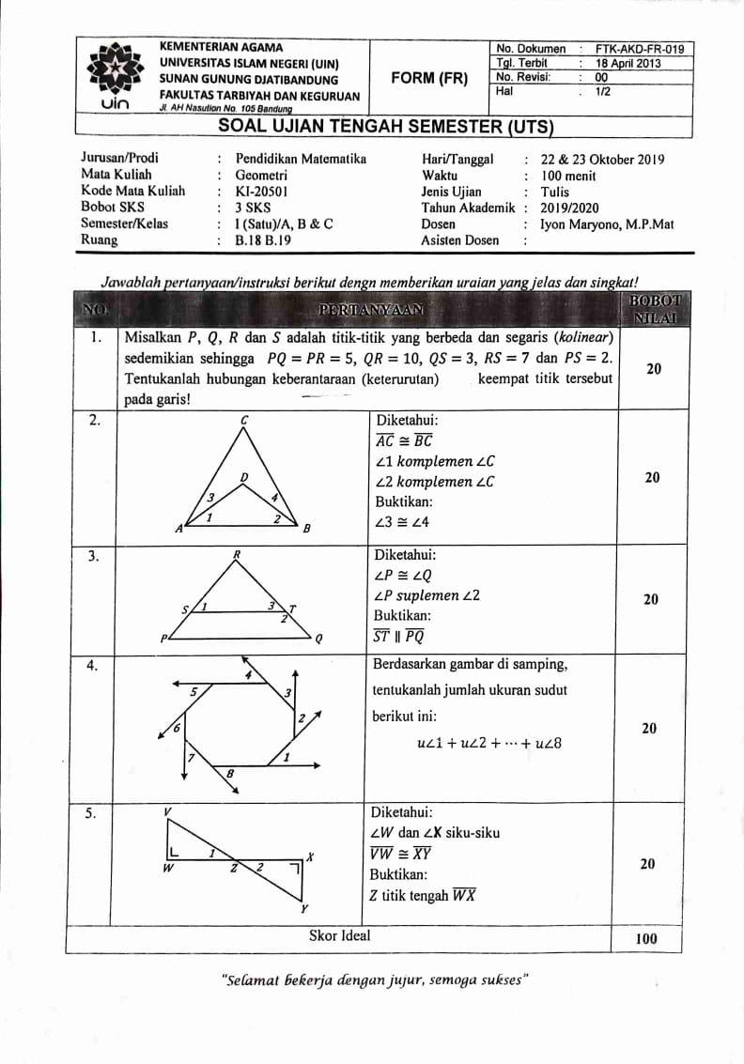
D- 3 Soal UTS

D- 4 Soal Kuis
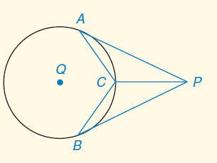
Diketahui bahwa $\overline{AP}$ dan $\overline{BP}$ adalah
garis singgung $⨀{Q}$ di A dan B
$\overline{PC}$ bisektor $∠APB$
Buktikanlah C adalah midpoint dari $\hat{AB}$

