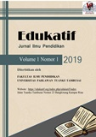

EDUKATIF: JURNAL ILMU PENDIDIKAN
Volume x Nomor x Tahun xxxx Halaman xx- xx
Research & Learning in Education
https://edukatif.org/index.php/edukatif/index

THE DEVELOPMENT OF CHEMICAL LEARNING BASED ON CHEMICAL COMMISSIONS TO IMPROVE CONCEPT MASTERY AND STUDENTS'
CREATIVE THINKING

Hisar Marulitua Manurung¹, Juni Agus Simaremare²

Universitas HKBP Nommensen Pematangsiantar^{1,2}
e-mail : hisarmanurung03@gmail.com¹ , simaremarejuniagus@gmail.com²

Abstrak
Penelitian ini bertujuan untuk mengembangkan pembelajaran berbasis komik kimia untuk meningkatkan penguasaan konsep dan berpikir kreatif siswa pada sifat koligatif larutan (SKL). Dalam penelitian ini pengembangan media komik kimia divalidasi dan diujicobakan dalam skala kecil dan besar. Data hasil belajar siswa yang meliputi aspek kognitif, afektif, dan psikomotorik dikumpulkan dengan menggunakan metode tes dan observasi dengan lembar observasi. Dari data yang diperoleh, besarnya pengaruh media komik kimia terhadap kemampuan berpikir kreatif dan penguasaan konsep siswa masing-masing sebesar 38,03% dan 22,17%. Penguasaan konsep dan berpikir kreatif pada kelas eksperimen lebih tinggi dibandingkan kelas kontrol. Perbedaan penguasan konsep dan berpikir kreatif tersebut disebabkan penggunaan media pembelajaran komik kimia dapat menarik perhatian siswa untuk belajar dan membuat suasana belajar mengajar lebih menyenangkan. Kesimpulan penelitian ini adalah terdapat pengaruh penggunaan media komik yang sudah dikembangkan terhadap daya pikir kreatif dan penguasaan konsep siswa pada materi sifat koligatif larutan.
Kata Kunci: Komik Kimia, Penguasaan Konsep, Berpikir Kreatif, dan SKL
Abstract
This study aims to develop comic chemistry-based learning to improve students' conceptual mastery and creative thinking on the colligative properties of solutions (SKL). In this study, the development of chemical comic media was validated and tested on a small and large scale. Data on student learning outcomes which include cognitive, affective, and psychomotor aspects were collected using the test and observation method with observation sheets. From the data obtained, the magnitude of the influence of chemical comic media on students' creative thinking skills and mastery of concepts was 38.03% and 22.17%, respectively. Mastery of concepts and creative thinking in the experimental class was higher than in the control class. The difference in concept mastery and creative thinking was due to the use of chemical comics learning media to attract students' attention to learning and make teaching and learning more enjoyable. This study concluded that there was an effect of using comics media that has been developed on the creative thinking power and mastery of students' concepts on the colligative properties of solutions.
Keywords: chemistry comics, concept mastery, creative thinking, and CPS.
Copyright (c) 2021 Hisar Marulitua Manurung, Juni Agus Simaremare
Corresponding author :
Email : hisarmanurung03@gmail.com ISSN 2656-8063 (Media Cetak)
HP : 081375682875 ISSN 2656-8071 (Media Online)

Received xx Bulan 2021, Accepted xx Bulan 2021, Published xx Bulan 2021

Introduction
Learning through own experience will be more meaningful and help children's development (Manurung, 2021). Logical and meaningful information for students is more meaningful than information learned by rote (Slavin, 2011). The digital era is an era of disruption where technological and communication advances occur very rapidly. In this era, the types of skills possessed and the existing jobs have begun to shift (Mercier & Sperber, 2011). Students feel the need to make some efforts to explore critical thinking and creative thinking competencies (Saptorini et al., 2014). The delivery of subject matter carried out by the teacher through a variety of methods is a success factor for students to master material (Pardimin et al., 2017). The teacher's role in learning is as a guide so that the learning activities experienced must be student-centered. Thus, students can develop knowledge, attitudes, and skills. For the teaching and learning process to be more adequate, efforts are made to determine the right strategy, optimal media, careful planning, and so on (Siahaan et al., 2021).
The sub-microscopic depiction is an important thing in the chemistry learning process. Teachers as educators must have high creativity to generate reasoning power and imagination of students in studying microscopic concepts so that chemistry learning in class is more logically acceptable so that it can have an impact on increasing students' motivation and learning outcomes. However, what is happening now is that the microscopic concept is not maximally conveyed to students which has an impact on decreasing motivation and learning outcomes. Talanquer, (2011) explains that chemistry involves understanding and applying concepts. The concept can be represented in various levels of multiple representations called chemical triplets, consisting of macroscopic (experimental and experience) representations, symbolic (chemical equations, chemical formulas, etc.), and sub-microscopic (molecules, electrons, atoms). Based on this, the teacher must have high creativity to be able to teach chemistry in the classroom, making it easier for students to understand each concept.
The depiction of phenomena that exist in chemistry can be done in various ways, for example by doing practicum, using teaching aids, teaching materials, or learning media. This is related to Samben's research, Samben, (2018) that one of the factors that influence the achievement of learning outcomes is the learning media used during the learning process. Meanwhile, the use of teaching materials, such as modules according to Kusumam et al., (2016) has benefits for both teachers and students, namely for teachers teaching materials used according to the curriculum, not depending on textbooks and government aid package books, while for students able to create interesting learning, foster motivation, reduce dependence and get convenience in studying every indicator contained in the learning tools prepared by the teacher. Seeing this, it is very necessary for chemistry learning media or innovative teaching materials in the learning process in the classroom. The existence of printed learning media that can help students learn is needed, considering that chemistry is one of the most difficult subjects. Seeing this, teaching materials are needed in the form of interesting and interactive modules for students. This is following the explanation of Manurung & Manurung, (2021) that the module is one type of tool in the form of learning tools that are used to help students to learn independently with self-instructional nature. That the use of the general chemistry module based on Problem based learning that was developed can make students play an active role and help them to master the concept of chemistry in the implementation of classroom learning (Manurung, n.d.).
Learning media are everything that can be used to channel messages or teaching content, stimulate students' thoughts, feelings, attention, and abilities so that they can encourage the teaching and learning process (Ibrahim & Syaodih, 2013). Chemistry teachers must choose and develop appropriate learning media so that students can easily understand the subject matter given. The development and use of learning media assisted by the latest digital technology devices is starting to become a research trend in the field of education, not least in the field of science education (Yektyastuti et al., 2015).
The right media can make the material presented to students real and clear, and make the process of presenting material effective and efficient (Ariani et al., 2020). On the other hand, the availability of various media is also beneficial, because students' styles or ways of learning are different. Some students have no difficulty understanding the information presented in the form of a series of words. However, there are also students, for whom verbal information only gives a vague or vague picture. So that students from the latter group can understand the material easily and clearly, the information presented in the form of learning media must be accompanied by a description or model (Sanova et al., 2016). Learning media accompanied by models can stimulate students' minds to find ideas contained in the media so that they can develop students' creativity. Creativity will be needed along with the development of knowledge. Students are required to come forward and compete to find new ideas that can simplify their lives.
Media that is suitable for the above is chemical comic media which is an interesting and fun learning medium Kusuma & Siadi, (2010) so that it can motivate students and make students interested in studying the colligative properties of solutions. Fun learning is learning with a teaching and learning atmosphere that makes students happy and pays full attention. Chemistry comics as a medium are expected to make learning more fun and meaningful.

RESEARCH METHOD
The diagram of the research design carried out is presented based on Figure 1. This research was carried out in the odd semester of the 2020/2021 academic year. The methods used in collecting research data are 1) Documentation method, used to obtain existing data, namely data on grades, notes, transcripts, books, newspapers, magazines, achievements, as well as a list of names and the number of class XII students who are the control class. and experiments; 2) This test method is used to take a score about the absorption of students in studying the colligative properties of solutions. A test is a series of questions or exercises and other tools used to measure skills, intelligence knowledge, abilities, or talents possessed by individuals or groups (Arikunto, 2006). The form of the test used is a multiple choice objective test with each.
XII-A Class
XII-B Class
Pretest
Pretest
Learning with illustrated comic media
Learning with conventional comic media
Post test
Post test
Study completeness test

Figure 1. Research Design Diagram
Each item has 5 alternatives (options). The test results will greatly affect the results of the study so that the test items used have been examined both for validity, reliability, level of difficulty of questions, and differentiating power of questions through instrument testing; 3) The Observation Sheet Method is used to determine student learning outcomes in affective and psychomotor aspects. Observations of the experimental and control group students were carried out during the learning process. This observation sheet includes indicators that can be used as a reference to measure student learning outcomes in affective and psychomotor aspects.

RESULTS AND DISCUSSION
This study aims to determine how the influence of chemical comic media on creative thinking and mastery of students' concepts in terms of cognitive, affective, and psychomotor aspects. To determine the effect of chemical comic media on students' creative thinking, the Mann-Whitney test was used. Based on the calculation results, the biserial correlation coefficient (cc) of students' creative thinking is 0.6167. So that the level of relationship between comic chemistry media and students' creative thinking is strong. Then from the price of the biserial correlation coefficient (cc), the coefficient of determination (CD) for students' creative thinking is 38.03%. Given that students' creative thinking is also influenced by several factors, it can be concluded that the magnitude of the effect of learning chemistry with chemical comics media on students' creative thinking on the subject matter of colligative properties of solutions is large. In comics, learning chemistry is accompanied by stories. stories in comics media can improve students' creative thinking because stories can invite students' curiosity so that students do not hesitate to ask questions and convey ideas, ideas, and opinions. Stories also encourage students to imagine. By imagining students can increase their creativity. An example of a page in a chemical comic that has been developed is presented in Figure 2.
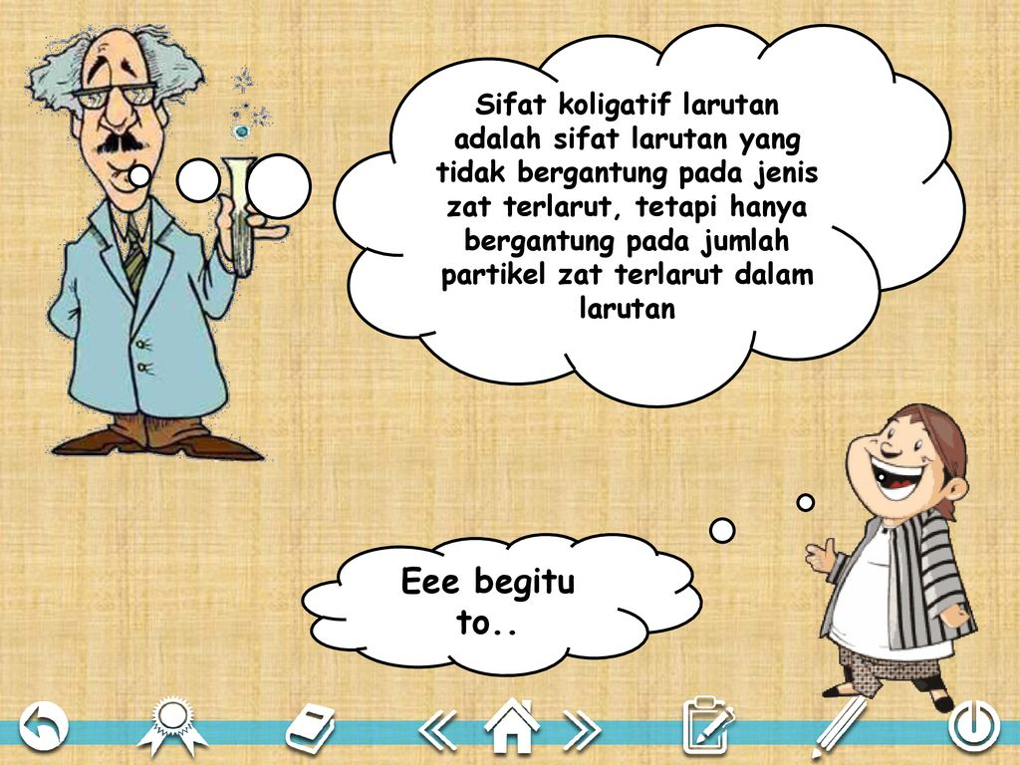
Colligative properties of solutions are properties that do not depend on the type of solute, but only on the number of solute particles in solution

Oh, I see …

Figure 2. Example of Pages in Chemistry Comics
Measurement of concept mastery is carried out using the test method (Roziyah & Kamaludin, 2019). The calculations used to determine the magnitude of the effect of learning with chemical comic media on students' creative thinking and conceptual mastery are the same as the calculation of the magnitude of the influence of chemical comic media on students' creative thinking. Based on the calculation results, it is obtained that the value of the biserial correlation coefficient (cc) for mastery of students' concepts is 0.4708. From these data, it can be concluded that the level of relationship between chemical comic media and students' mastery of concepts is moderate. From the price of the biserial correlation coefficient (cc), the value of the coefficient of determination (KD) for the mastery of students' concepts is 22.17%. Given that students' mastery of concepts is also influenced by several factors, it can be concluded that the effect of learning with chemical comics media on students' creative thinking and mastery of concepts is large.
In measuring the affective aspect, the observation method was used using an observation sheet. At the time of learning takes place in addition to carrying out the teaching and learning process, the task of the teacher here is also as a researcher to observe students on the affective aspect.
In this study, researchers used 7 indicators that can be used to measure student learning outcomes in the experimental class and the control class on cognitive aspects. The data obtained can be described by a graph of the percentage of the total score obtained for each indicator in the experimental class and control class. In addition, the data obtained can also be described by a graph of the percentage of the number of students who achieved an increase in creative thinking and mastery of concepts in the affective aspects of the high, medium, and low categories between the experimental class and the control class. The relationship between the indicators and the average student score for each indicator of the affective aspects of the experimental class and control class students is presented in Figure 3.
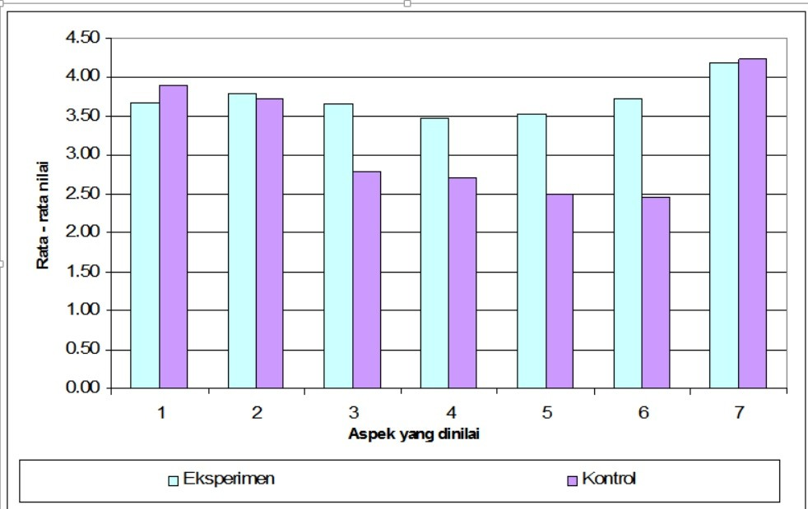
Rated aspect

Figure 3. The relationship between the indicators and the average
student score for each indicator of the affective aspects of the
experimental class and control class students
The data above shows that the score of the experimental class in the affective aspect is better than the control class because learning with chemistry comics media will make students more interested and pay attention to the teacher's explanation, asking and answering questions. This can be since learning by using chemical comics media can invite students' curiosity so that in the learning process students will be more active in paying attention to the teacher's explanations, asking questions, answering questions, giving and expressing opinions, and being able to complete assignments well (Lubis & Ikhsan, 2015). When viewed from the average value of each aspect of the assessment, it shows that there are two aspects of assessment in the control class that have a higher average value than the experimental class, namely bringing notebooks, packages/LKS, and completing the assigned tasks. This can be caused because these two things are routine activities carried out by students in every learning activity.
Other research results obtained are student learning outcomes in psychomotor aspects. The assessment of the psychomotor aspect is carried out using the observation method when students carry out practical activities. In this study, both the experimental and control classes were given the same practicum. Based on research data on psychomotor aspects, in the experimental class, it can be seen that all aspects of the assessment include preparation of practicum tools, skills in using tools, the accuracy of practical procedures, accuracy in observing experiments, teamwork in groups, results of practicum, cleanliness of tools and rooms, and the preparation of interim reports have reached the medium category. While in the control class there is still one aspect of assessment that only reaches the low category, namely the accuracy of practical procedures. Meanwhile, the other aspects of the assessment have reached the medium category. The relationship between the indicators and the average student score for each indicator of the psychomotor aspects of the experimental class and control class students can be seen in Figure 4.
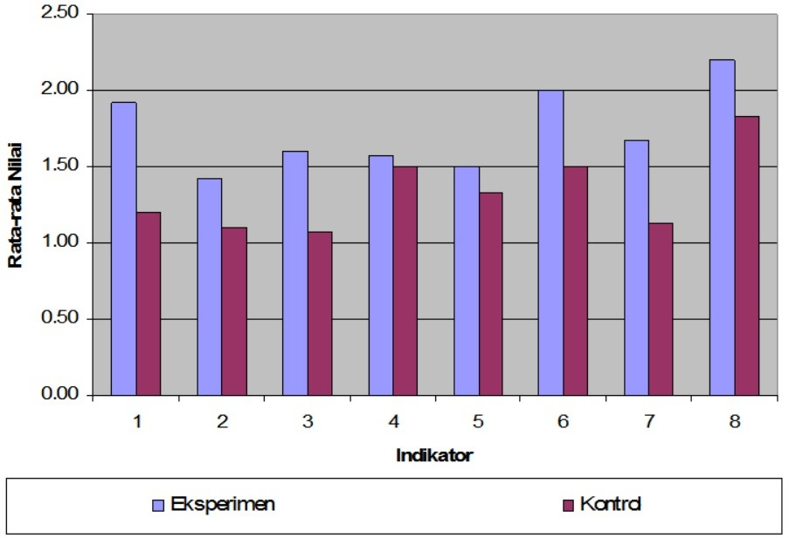

Figure 4. The relationship between indicators and students' average
scores for the experimental class and the control class
In the experimental class, before carrying out practicum activities students were given the material for reducing vapor pressure and freezing point depression using chemical comics media so that students felt interested in proving the truth of the stories in chemical comics when learning was carried out in the laboratory. This reason can then make students more serious and careful in carrying out the practicum. With the sincerity of students in carrying out the practicum, the errors in carrying out the practicum will be reduced and the mastery of students' concepts in the psychomotor aspect can be increased. In addition, in the experimental class, if there are students who have difficulty in carrying out practicals, they do not hesitate to ask the teacher. But in the control class, learning is only carried out conventionally, students are not given the material for reducing vapor pressure and decreasing boiling point with chemical comic media so that students feel less interested in carrying out practicals.
Learning media is one of the components of learning that cannot be ignored because with the right learning media the teacher can convey learning material more easily and students become more helpful in capturing the material presented by the teacher (Dharma Santi Gomulya, 2018). The function of learning media here is to channel messages or teaching content, stimulate students' thoughts, feelings, concerns, and abilities so that they can support the teaching and learning process. The use of appropriate learning media can make the learning process more meaningful. One of the learning media that can make learning more meaningful and fun for students is learning media that use the CET (Chemo-edutainment) approach. CET media is an interesting and fun learning media so that it can motivate students and make students interested in learning chemistry.
Several studies on CET media have been carried out including by Afandi, (2015) who also researched with the title Development of Learning Media for Snakes and Ladders Game to Improve Student Motivation and Social Studies Learning Outcomes in Elementary Schools. The results showed an increase in student learning outcomes by 66.7% (Afandi, 2015). Nugraha, (2020) researched the Development of Chemoedutainment Learning Media for Science-Chemistry Subjects in Junior High School. The results showed that the respondents gave a fairly good appreciation of the chemo-edutainment learning media that was being piloted. The design of science-chemistry learning media for junior high school students has been successfully made in the form of a VCD by including aspects that need to be included in the junior high school science-chemistry learning media package according to the characteristics of junior high school students. The concept of Chemo-edutainment in the VCD model of learning media for junior high school students is a concept that needs to be realized in the form of innovative and interesting learning media. The learning media that has been developed has received a good enough response to be used as a medium for learning chemistry in junior high schools, both in the classroom and at home (Nugraha, 2020).
The use of chemo-edutainment-based ingenious circuit media in acid-base solution learning has been studied by Priatmoko & Diniy, (2012). The results of this analysis indicate that there are differences in learning outcomes between the experimental class and the control class. In addition, the results of the analysis of observational data showed that the affective and psychomotor learning outcomes of the experimental class were better than the control class. The experimental class has achieved classical completeness while the control class has not. Based on the results of the study, it can be concluded that the use of intelligent circuits has a positive effect on student learning outcomes in chemistry learning the subject matter of acid-base solutions. Research that produces learning media based on chemo-edutainment models of instructional games on electron configuration material and knowing the responses of teachers and students to the developed media was carried out by (Bahriah et al., 2017). The results of the study show that the learning media developed has educational value and is entertaining for its users. The results of the limited trial got a teacher response score of 84.09% which was included in the very good category. The results of student responses get a total score of 82.88% with very good criteria (Bahriah et al., 2017).
Seeing that there is a positive effect on learning chemistry with chemical comics media on creative thinking and students' mastery of concepts on the subject matter of colligative properties of solutions, as well as positive responses from students, chemical comics can be used by teachers as reference material in the implementation of learning with the Chemo edutainment approach (CET) in general and chemical comics media in learning chemistry, the subject matter of colligative properties of solutions has an impact on students to explore their potential again and for teachers to create an interesting learning atmosphere.

CONCLUSION
From the discussion above, it can be concluded that there is an effect of using comics media on students' creative thinking and conceptual mastery because using chemical comics media can increase students' creative thinking and mastery of concepts in cognitive, affective, and psychomotor aspects. It can also be concluded that CET (Chemo edutainment) media is a suitable media to be able to make chemistry learning more interesting and fun so that students do not feel bored in studying chemistry because the material provided is packaged in an attractive form.
Suggestions related to the results of this study include chemistry teachers can use chemical comics media in learning chemistry on the subject matter of colligative properties of solutions to improve students' creative thinking and mastery of concepts. In addition, in learning chemistry, the teacher should be able to direct students so that students' attention is not only on the fun things contained in the CET media but also focuses on learning material colligative properties of solutions.

ACKNOWLEDGMENT
Acknowledgments are expressed by the researchers to the dean of the faculty of teacher training and education, the head of the chemistry education study program, school principals, and teachers so that researchers can complete research in the form of journal publications.

REFERENCES
Afandi, R. (2015). Pengembangan media pembelajaran permainan ular tangga untuk meningkatkan motivasi belajar siswa dan hasil belajar IPS di sekolah dasar. JINoP (Jurnal Inovasi Pembelajaran), 1(1), 77–89.
Ariani, S., Effendy, E., & Suharti, S. (2020). Model Mental Mahasiswa Pada Fenomena Penghilangan Karat Melalui Elektrolisis. Chemistry Education Practice, 3(2), 55–62.
Arikunto, S. (2006). Prosedur penelitian pendekatan praktek. Jakarta: Rineka Cipta.
Bahriah, E. S., Feronika, T., & Suharto, H. (2017). Pengembangan Media Pembelajaran Berbasis Chemo-Edutainment Melalui Model Instructional Games Pada Materi Konfigurasi Elektron. Jurnal Riset Pendidikan Kimia (JRPK), 7(2), 132–143.
Dharma Santi Gomulya, I. (2018). Pengembangan Ludo Word Game (LWG) Kimia sebagai Media Chemo-Edutainment (CET) pada Materi Sistem Koloid Kelas XI SMA/MA. Menara Ilmu, 12(12).
Ibrahim, R., & Syaodih, N. (2013). Rencana Pengajaran. Rineka Cipta, Jakarta.
Kusuma, E., & Siadi, K. (2010). Pengembangan bahan ajar kimia berorientasi chemo-entrepreneurship untuk meningkatkan hasil belajar dan life skill mahasiwa. Jurnal Inovasi Pendidikan Kimia, 4(1).
Kusumam, A., Mukhidin, M., & Hasan, B. (2016). Pengembangan bahan ajar mata pelajaran dasar dan pengukuran listrik untuk sekolah menengah kejuruan. Jurnal Pendidikan Teknologi Dan Kejuruan, 23(1), 28–39.
Lubis, I. R., & Ikhsan, J. (2015). Pengembangan media pembelajaran kimia berbasis android untuk meningkatkan motivasi belajar dan prestasi kognitif peserta didik SMA. Jurnal Inovasi Pendidikan IPA, 1(2), 191–201.
Manurung, H. M. (n.d.). PENGARUH MODUL KIMIA UMUM BERBASIS PROBLEM BASED LEARNING (PBL) TERHADAP PENGUASAAN KONSEP MAHASISWA PADA MATERI STOIKIOMETRI. Quantum: Jurnal Inovasi Pendidikan Sains, 12(1), 82–90.
Manurung, H. M. (2021). Model Pembelajaran Kimia Kreatif Berbasis PBL Menggunakan Macromedia Flash.
Manurung, H. M., & Manurung, S. (2021). The Relationship between Learning Motivation and Learning Outcomes of Students Chemistry of Grade XI-MNS in 4 State SHS Pematangsiantar. PENDIPA Journal of Science Education, 5(3), 466–471.
Mercier, H., & Sperber, D. (2011). Why do humans reason? Arguments for an argumentative theory. Behavioral and Brain Sciences, 34(2), 57–74.
Nugraha, D. A. (2020). Pengembangan Komik Kimia Sebagai Media Pembelajaran Berbasis Cet (Chemo-Edutainment). Chemistry in Education, 9(2), 84–90.
Pardimin, P., Widodo, S. A., & Purwaningsih, I. E. (2017). Analisis butir soal tes pemecahan masalah matematika. Wacana Akademika: Majalah Ilmiah Kependidikan, 1(1).
Priatmoko, S., & Diniy, H. H. (2012). Penggunaan Media Sirkuit Cerdik Berbasis Chemo-Edutainment dalam Pembelajaran Larutan Asam Basa. Jurnal Pendidikan IPA Indonesia, 1(1).
Roziyah, D. A., & Kamaludin, A. (2019). Pengembangan Modul Kimia Berbasis Chemoedutainment (CET) Pada Materi Reaksi Redoks. Journal of Tropical Chemistry Research and Education, 1(1), 21–28.
Samben, S. (2018). Pengaruh Minat dan Kebiasaan Belajar Terhadap Prestasi Belajar. Eklektika: Jurnal Pemikiran Dan Penelitian Administrasi Pendidikan, 2(1), 60–66.
Sanova, A., Epinur, E., & Afrida, A. (2016). Implementasi Penggunaan Game Simulation Sebagai Media Chemo-Edutainment dengan Pendekatan Chemo Entrepreneurship untuk Meningkatkan Minat, Life Skill dan Hasil Belajar. Journal of The Indonesian Society of Integrated Chemistry, 8(1), 12–23.
Saptorini, S., Widodo, A. T., & Susatyo, E. B. (2014). GREEN CHEMISTRY DALAM DESAIN PEMBELAJARAN PROJECT-BASED LEARNING BERBASIS KARAKTER DI MADRASAH ALIYAH SE-KABUPATEN DEMAK. Rekayasa: Jurnal Penerapan Teknologi Dan Pembelajaran, 12(1), 57–69.
Siahaan, K. W. A., Lumbangaol, S. T. P., Marbun, J., Nainggolan, A. D., Ritonga, J. M., & Barus, D. P. (2021). Pengaruh Model Pembelajaran Inkuiri Terbimbing dengan Multi Representasi terhadap Keterampilan Proses Sains dan Penguasaan Konsep IPA. Jurnal Basicedu, 5(1), 195–205.
Slavin, R. E. (2011). Cooperative learning. Learning and Cognition in Education, 160–166.
Talanquer, V. (2011). Macro, submicro, and symbolic: the many faces of the chemistry “triplet.” International Journal of Science Education, 33(2), 179–195.
Yektyastuti, R., Prasetyo, Y. D., Mardiana, T., Ikhsan, J., & Sugiyarto, K. H. (2015). Penggunaan Media Pembelajaran Kimia “Chemondro” Pada Materi Kelarutan Dan Pengaruhnya Terhadap Kemandirian Belajar Siswa Sma. Prosiding SNPS (Seminar Nasional Pendidikan Sains), 2, 80–87.

