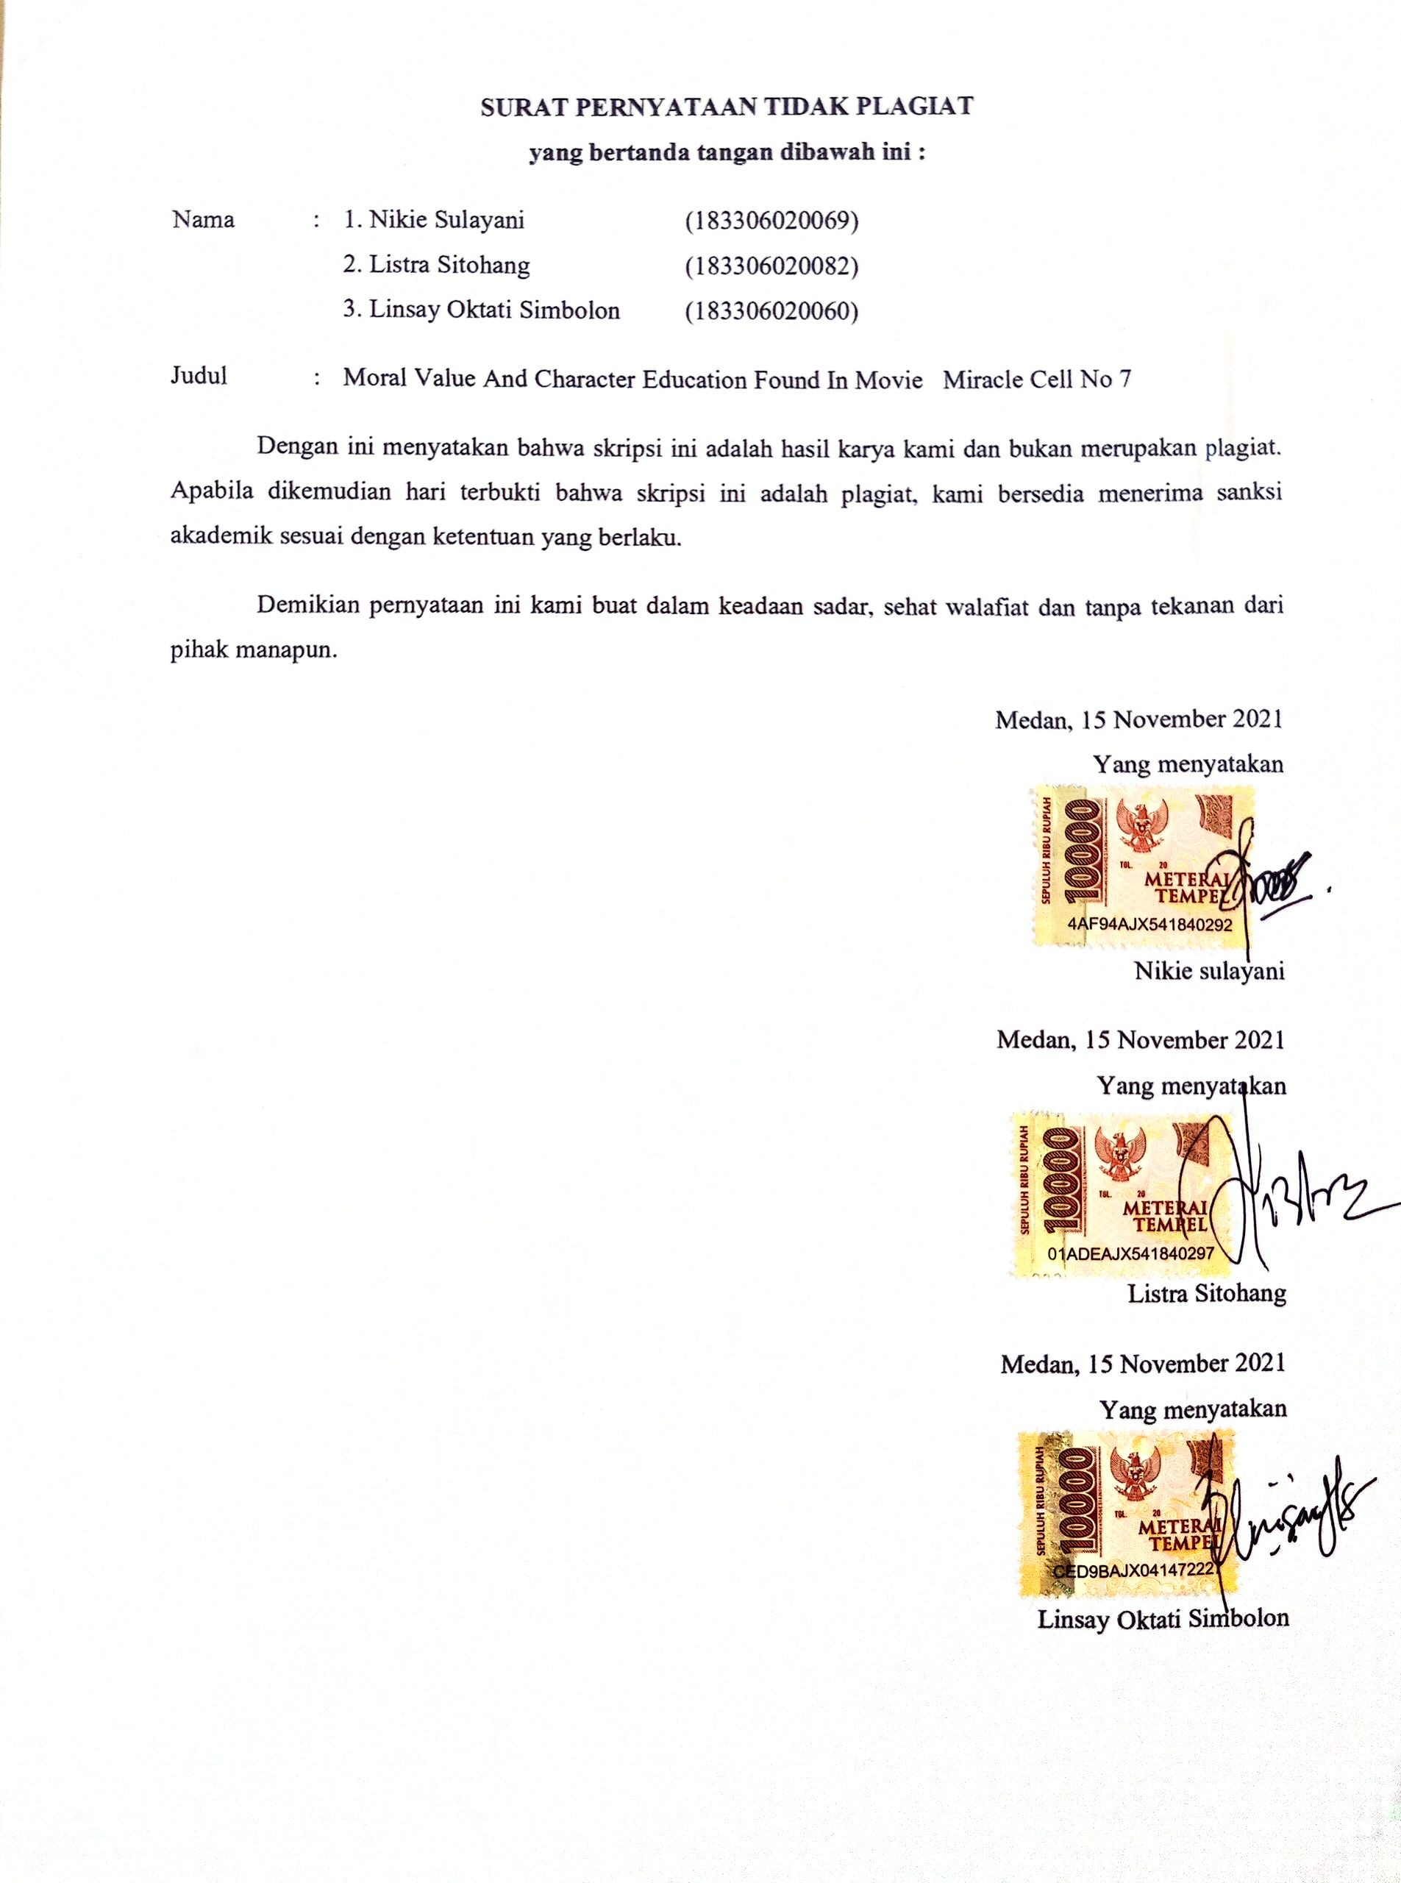

APPENDIX 1
Cover photo of Miracle in Cell no.7 Film

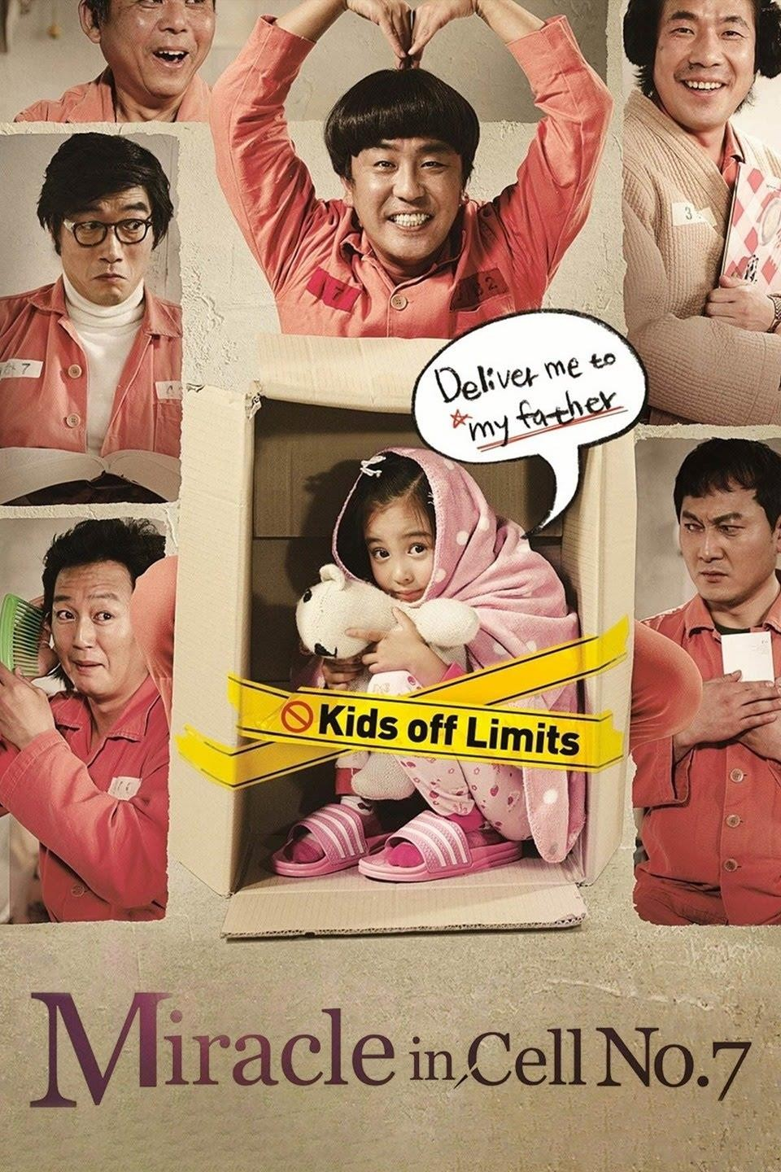

APPENDIX 2
Photo while sharing research questionnaires to class X TKR students at SMK 2 TR Sinar Husni, Deli Serdang Medan.
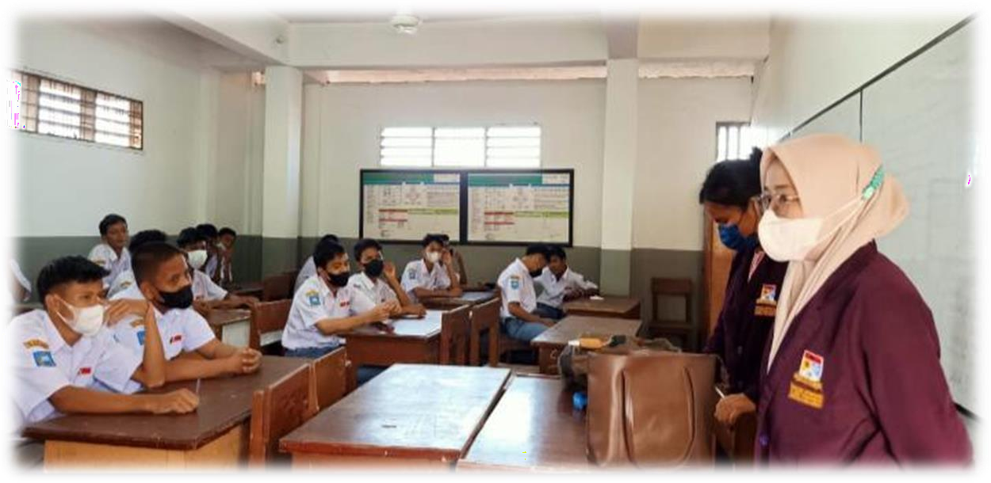

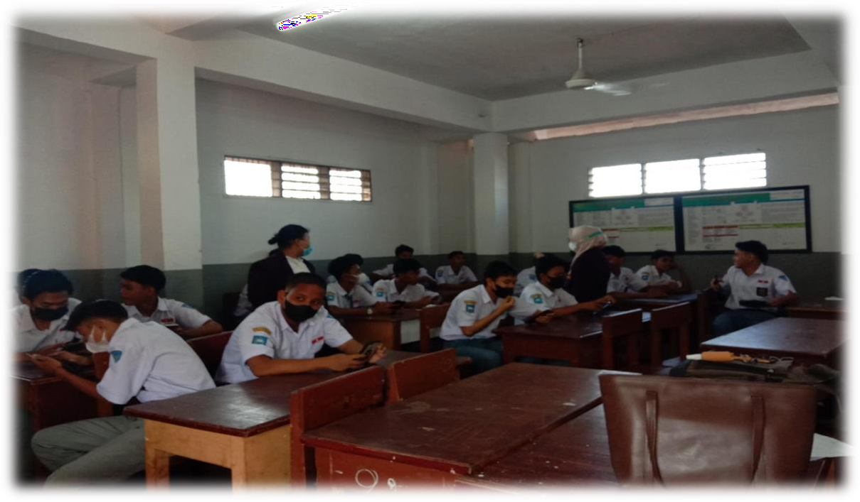

APPENDIX 3
The names of students who filled out the research questionnaire

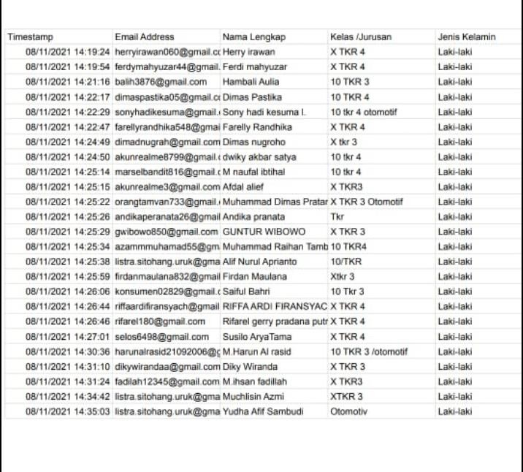

APPENDIX 4
Synopsis of the movie Miracle In Cell No. 7

Movie Miracle in Cell No. 7 is one of the saddest films made in Korea. This film is directed by Lee Hwan Kyung and was first released on March 8, 2013. This film has a duration of 02 hours 07 minutes which tells of a father named Lee Yong Goo (RyooSeung-Ryong) who has mental retardation. He has a little daughter named Ye Sung, played by Kal So-won (little Ye Sung) and Park Shin Hye (adult Ye Sung).

The beginning of this story is when Ye Sung has one wish. his desire was very simple, namely to buy a yellow bag with the image of Sailor Moon. Ye Sung and his father always pass by the bag shop to peek through the glass, and wish they could have the Sailor Moon bag soon. However, the father does not have the money to buy the bag.

Until one day, when the father got a salary from his job as a parking attendant, they went to a bag shop to buy it. However, the only bag was already in the hands of the buyer, a daughter of a police commissioner.The father asked the boy to sell her bag to Ye Sung. However, the child did not want to give it. After that, the son of the police commissioner went to Lee Yong Goo to tell him that there was another shop selling the same bag.

Her father followed the girl. However, trying to follow the child fell on the road and died. From here, Lee Yong Goo was caught in a serious case with accusations of sexual violence, kidnapping, and murder.In the end, Ye-sung separated from her father. Because Lee Yong Go had to go to jail for his charges. Ye Sung was sent to a foster care institution. His father was put in prison cell number 7, which is a cell that has a high level of security.

Lee Yong Goo was tortured while in the cell, because at first the occupant of cell no.7 knew that the cause of Lee Yong Go's entry into prison was sexual violence against minors which was considered a fatal crime.Soon after, several incidents prove that Lee Yong Goo is someone who has a kind, helpful heart. The other inmates also began to be kind to him. They began to be friends. Because of his father's good deeds, cell no. The 7 also wanted to grant his request, which was to meet her son Ye Sung.Finally, the occupants of cell no.7 took Yee Sung secretly into the cell. When Ye Sung came into the cell it was very moving and tense.

After that, his friends tried to help Lee Yong Goo to prove his innocence at trial later. They also helped his father to practice continuously. When the trial took place, everyone was shocked by Lee Yong Goo's confession which was either outside his training or outside the truth. He admitted that he had committed all the crimes charged against him. This turned out to be a threat from the police commissioner who was the father of the dead child. The commissioner threatens to endanger his daughter Ye Sung if Lee Yong Goo doesn't admit to a crime he didn't actually commit.

His affection and love for his little daughter Ye Sung made him admit the accusations against him. Until Lee Yong Goo was sentenced to death on charges that were not at all his doing. When Ye Sung grew into an adult, he became friends with the other occupants of cell no.7 who were friends of her father. And that's when Ye Sung re-investigated the incident, and proved that his father Lee Yong Goo was innocent, even though his father had died.

Actors and Actress from the film Miracle In Cell No. 7

Ye-sung's father (Lee Yong-gu) : RyuSeung-ryong Little (Yesung) : Kal so-won
Ye-sung adult : Park Shin-hye So
Yang ho (gangster) : Oh Dal-su Jang Min-hwan(chief warden) : Jung Jin-young
Choi Chun-ho (swindler) : Park Won-sang
Kang Man-beom : Kim Jung-tae
Shin Bong-shik : Jung Man-shik
Elder Seo : Kim Gi-cheon
Ye-sung's teacher : Han bi-jung
Chief of Police : Jo Deok-hyun.

